SENSITIVE MEN RISING
— — —
The Complete Story: Episodes I, II & III
The Awakening · The Sensitive Child · The Sensitive Warrior
Featuring the voices of:
Dr. Elaine Aron · Alanis Morissette · Peter Coyote · Luke Goss · Scott Barry Kaufman, Ph.D. · Dr. Tracy Cooper
Dr. Tom Falkenstein · Dr. Michael Pluess · Dr. Bianca Acevedo · Boy Abunda · Soborno Isaac Bari · Dr. Jed Diamond
Daniel Miller, Ph.D. · Alane Freund · Arthur Aron, Ph.D. · Juri Masaki · Mark Jamison · Cecil Williams
Andrew Reis · Greg Johnson · Jacquelyn Strickland · Susan Fisher-Crooks · Brian Torres · Andy Lightfoot · Saamdu Chetri · Kokoi Baldo · Luke Goss · and many more
Directed by Will Harper
The Sensitive Director

Sensitive Men Rising: The Complete Story — Episodes I, II & III

Copyright © 2026 Will Harper
All rights reserved. No part of this publication may be reproduced, distributed, or transmitted in any form or by any means, including photocopying, recording, or other electronic or mechanical methods, without the prior written permission of the publisher, except in the case of brief quotations embodied in critical reviews and certain other noncommercial uses permitted by copyright law.

The transcripts in this book are drawn from the Sensitive Men Rising documentary series. All speakers have participated with their consent. Their words have been lightly edited for clarity and readability while preserving the authentic voice and meaning of each contributor.

First Edition, 2026

Sensitive Men Rising is dedicated to the memory of Dr. Ted Zeff (1947–2019) — pioneer, visionary, and tireless advocate for highly sensitive men everywhere. He was always far ahead of his time.

About Sensitive Men Rising
Sensitive Men Rising is a landmark documentary series directed by Emmy Award Winning filmmaker Will Harper — The Sensitive Director. It is the companion to the acclaimed documentary Sensitive: The Untold Story, which introduced millions of viewers worldwide to the science of Sensory Processing Sensitivity as identified by Dr. Elaine Aron.
This book brings together the complete transcripts from all three episodes of the documentary, presenting the unfiltered words of scientists, artists, athletes, advocates, and everyday men who have found their way through a world that did not always have room for their depth.
Episode I — The Awakening introduces the science and the history of high sensitivity in men, and asks the essential question: what does it truly mean to be a man?
Episode II — The Sensitive Child explores how sensitive boys are shaped by their environments, and what parents, teachers, and caregivers can do to help them thrive.
Episode III — The Sensitive Warrior presents the sensitive man as a force for leadership, change, and healing in the world — and asks what happens when sensitive men finally rise.

The voices in this book represent more than forty contributors from across the world — researchers, musicians, psychologists, athletes, filmmakers, advocates, and ordinary men living extraordinary lives. Together, they offer the most comprehensive and human portrait of male sensitivity ever assembled.

— — —
"The time is now. It's time for sensitive men to rise."
— Peter Coyote

Table of Contents
EPISODE I — THE AWAKENING
Introduction: What Is a Man? — Alanis Morissette & Peter Coyote
Chapter 1: What Is High Sensitivity? — Dr. Elaine Aron
Chapter 2: The Two Survival Strategies — Peter Coyote
Chapter 3: The Science of High Sensitivity
Chapter 4: The S Word — Scott Barry Kaufman & Andy Lightfoot
Chapter 5: A Whole, Full Man — Alanis Morissette
Chapter 6: In His Own Words — Luke Goss & The Man I Am
Chapter 7: A Legacy of Sensitivity — Dr. Ted Zeff
Chapter 8: Boy Abunda — Coming From the Poorest Province
Chapter 9: The Brain Science of High Sensitivity — Dr. Bianca Acevedo
Chapter 10: High Sensitivity and ADHD
Chapter 11: Coping — Andy Lightfoot & Daniel Miller, Ph.D.
Chapter 12: The High Sensation Seeker
Chapter 13: The Most Wonderful Thing — Dr. Elaine Aron
Closing: The Path Forward

EPISODE II — THE SENSITIVE CHILD
Introduction: Differential Susceptibility and the Sensitive Boy
Chapter 8: Signs Every Parent Should Know — Dr. Ted Zeff
Chapter 9: Walt's Story — Susan Fisher-Crooks
Chapter 10: What Sensitive Boys Need Most — Daniel Miller, Ph.D.
Chapter 11: Boy Abunda — Count Yourself In
Chapter 12: Dr. Michael Pluess — The Ideal Environment
Chapter 13: Dr. Kim Fullerton Nelson — Raising a Sensitive Son
Chapter 14: Soborno Isaac Bari — The Highly Sensitive Boy
Chapter 15: Dr. Elaine Aron & Tim Jackson — Family Is Everything
Chapter 16: Kai Martin — Social Media and the Sensitive Teen
Chapter 17: Luke Goss — Ambassadors for Life
Chapter 18: Rebecca Taylor Shaw — The Sensitive Boy Who Pushed Back
Chapter 19: Brian Torres — Sensitivity and the LGBTQ+ Community
Chapter 20: Greg Johnson — Finding Your Voice
Chapter 21: Dr. Tom Falkenstein — The Message That Changes Everything
Chapter 22: Scott Barry Kaufman — Own It
Chapter 23: Dr. Tracy Cooper — The Nurturing Environment
Chapter 24: Joseph Keon — Surviving Violence, Finding Strength
Chapter 25: Tom Falkenstein & Luke Goss — Men Who Model Sensitivity
Chapter 26: Alanis Morissette — Raising Sensitive Sons
Closing: It's Time for a New Chapter

EPISODE III — THE SENSITIVE WARRIOR
Introduction: The Warrior Within — Peter Coyote
Chapter 29: Luke Goss — Warriors Sit Within Truth
Chapter 30: Dr. Tom Falkenstein — Redefining Manhood
Chapter 31: Scott Barry Kaufman — Strong With Your Sensitivity
Chapter 32: Will Harper — The Sensitive Warrior Spirit
Chapter 33: Dave Reno — It's Been Raining a Long Time
Chapter 34: Pastor Marvin White — Rising Up Together
Chapter 35: Andy Lightfoot — One Tribe
Chapter 36: Arthur & Elaine Aron — Advisors and Warriors
Chapter 37: Dr. Jed Diamond — The Calling
Chapter 38: William Allen — A Clarion Call
Chapter 39: Saamdu Chetri — The Strongest Human Being
Chapter 40: Will Harper & Juri Masaki — Japan's Quiet Revolution
Chapter 41: Andrew Reis — A Tradesman's Awakening
Chapter 42: Peter Coyote — The Warrior's S.T.Y.L.E.
Chapter 43: Mark Jamison — Sensitivity at Visa
Chapter 44: Greg Johnson & Cecil Williams — Lead With Sensitivity
Chapter 45: Alanis Morissette — Born to Support HSP Leaders
Chapter 46: Dr. Tracy Cooper — Conscious Leadership
Chapter 47: Asher Freund — The Sensitive EMT
Chapter 48: Dr. Elaine Aron — The Sensitive Leader's Style
Chapter 49: John Hughes & Daniel Miller — The Next Generation
Chapter 50: Jacquelyn Strickland — Rise Above
Chapter 51: Rev. Marvin White — Love and the Metaphysical
Chapter 52: Susan Fisher-Crooks — Pass It Forward
Chapter 53: Scott Barry Kaufman — Embrace the Unknown
Chapter 54: Kokoi Baldo & Alanis Morissette — It's a Gift
Chapter 55: Luke Goss — Tenacity of Spirit
Closing: The Time Is Now — Peter Coyote & Luke Goss

EPISODE I
The Awakening
Discovering Who You Are and Why It Matters

Table of Contents
Introduction: What Is a Man? — Alanis Morissette & Peter Coyote
Chapter 1: What Is High Sensitivity? — Dr. Elaine Aron
Chapter 2: The Two Survival Strategies — Peter Coyote
Chapter 3: The Science of High Sensitivity — Dr. Tracy Cooper, Dr. Michael Pluess & Dr. Tom Falkenstein
Chapter 4: The S Word — Scott Barry Kaufman & Andy Lightfoot
Chapter 5: A Whole, Full Man — Alanis Morissette & Scott Barry Kaufman
Chapter 6: In His Own Words — Luke Goss & The Man I Am
Chapter 7: A Legacy of Sensitivity — Dr. Ted Zeff
Chapter 8: Boy Abunda — Coming From the Poorest Province
Chapter 9: The Brain Science of High Sensitivity — Dr. Bianca Acevedo
Chapter 10: High Sensitivity and ADHD — Marc Almodovar & Dr. Bianca Acevedo
Chapter 11: Coping — Andy Lightfoot & Daniel Miller, Ph.D.
Chapter 12: The High Sensation Seeker — Dr. Tracy Cooper & Dr. Bianca Acevedo
Chapter 13: The Most Wonderful Thing — Dr. Elaine Aron
Closing: The Path Forward — Peter Coyote

Introduction
What Is a Man?
Alanis Morissette — 7× Grammy Award Winning Singer-Songwriter & Musician
This is a movement that is allowing those of us in the 20 to 30% who are highly sensitive — it's our moment in the sun in a way, because I've always felt that the meek won't inherit the Earth. The HSPs shall inherit the Earth — because we're the ones that are looking at every single detail. That acronym of DOES has just been so helpful over the years: Depth of processing, Overstimulation, Empathic, and then the Sensitivity to subtleties and pickings up on subtle messagings and considerations, whether it's lighting or sound or nutrients or space being left for an emotional healing experience. I want to be in the hands of a highly sensitive person when I'm in the pay dirt of deep inner work.
Peter Coyote — Narrator & Actor
The house I grew up in — my father was a prizefighter and a black belt in judo, knocking people out and going to jail in his 60s. He represented a certain kind of masculine authority, which I looked up to and emulated for a long time. I spent a lot of time with rough men trying to come to terms with that.
But over time, your intuitions begin to talk to you and you realize that the potential of being a man is much more than that. A man is a father. A man is an uncle. A man is a caregiver. A man is a protector. A man is a warrior. And I realized that the people that I most admired and liked the most were what you could call highly sensitive men. They weren't effeminate, they weren't weak, but they had the full spectrum of their capacities available to them.
And that full spectrum is what balances masculine violence and masculine competitiveness and masculine domination. The world is full of examples of places where men have learned to corral and harness their dominant masculine traits — and give them to the group, heal themselves of trauma, heal themselves of anger and rage, and try to become members of a community.
I agreed to do this film because these people were speaking to something that I thought was under-defended, underspoken to. The time is now. And what now requires is for sensitive men to have confidence and to rise into their natural authority.
— — —

Chapter 1
What Is High Sensitivity?
Dr. Elaine Aron — Clinical Researcher, Psychologist, Bestselling Author
Sensitivity is one temperament trait, and by temperament we mean something that we think is inborn — there from birth. And it colors all of the personality, which personality is kind of a combination of life experiences and how you grew up, and what's innate, what's in the DNA.
I'm really delighted that we are making this movie about highly sensitive men. It's been in the back of my mind and the back of my heart for a long time, as long as I've been studying this trait. Sensitive men have suffered a lot, especially in what I call the immigrant cultures in North and South America and Australia — these places where we have assumed that toughness works best. I want to make very clear about the nature of sensitivity as a survival strategy that involves watching and observing — and then acting creatively, intelligently, in a way that those who move quickly do not always have at their disposal. So sensitive men are different.
The misunderstanding is that when you see someone who is watching and thinking and observing and planning, you can misunderstand. You can think that they're weak, that they are indecisive, that they are aloof, that they're not very intelligent. Sensitive men, I think most of them have, over the years, learned to look different, to act decisively, to be tough. But that really spoils who they really are, and they feel like they're living a double life.
So what we want is for them to not have to do that anymore and to be fully appreciated. Because what we need now in the world more than anything is people who do think twice before acting, who do see the big picture, and that's what sensitive men are designed to do.
— — —
Chapter 2
The Two Survival Strategies
Peter Coyote — Narrator
Since the dawn of large animals, biologists agree that individuals in most species have been born with one of two survival strategies. The aggressive majority use: be first at all costs. The sensitive minority use: watch before acting.
Both can be successful and exist side by side. In humans, both can be hunters, warriors, protectors of the family — but with different styles. However, as nations have replaced tribes and guns have replaced arrows, some of the majority have used aggression to amass power and abuse the weak. The sensitive minority, ignored and sometimes bullied, have receded further into their quiet watching. This has to change. This must change.
This film has the capability of changing the lives of so many men — men who may not be aware that they're part of the hundreds of millions of men in the world who share a remarkable personality trait called sensory processing sensitivity.
It has been decades since Dr. Elaine Aron first properly saw this innate temperament trait. She and her husband Arthur Aron have been publishing scientific studies about it since 1997, identifying it as sensory processing sensitivity. High sensitivity was always there, of course, usually wrongly seen as shyness or introversion. It is neither of these. It was also sometimes seen as uptight, weak, or neurotic. In men, as weakness — being soft, a sissy.
Now many see sensitivity as a gift. Some even call it a superpower. This film is not interested in labels. We are interested in exploring the global contribution that waking up this instinctive, intuitive understanding can offer us. We want sensitive men to realize that their intellectual, intuitive, and instinctive capacities are part of the nature of the universe. To trust them, to live in alignment with them, to live lives of their highest aspirations. Right now it's not a stretch to say that most of the world's problems stem from a certain kind of dominating, competitive male psychology that's been held as the standard for four or five thousand years. We are confident that a different kind can change that.
— — —

Chapter 3
The Science of High Sensitivity
Dr. Tracy Cooper — Ph.D., HSP Author, Educator & Consultant
People at the high end of it need to be aware that you process things more deeply. You feel things more deeply. You experience life in a more intense way. You have a tendency to be overstimulated before others — your bar for overstimulation is lower than for other people. That's important to understand because that brings a self-care aspect into it. You're higher in empathy and you have a broader emotional range. You're also sensitive to subtle cues. So once you understand how that model works, you can really understand the way that you are hardwired to function.
Dr. Michael Pluess — Professor, School of Biological and Behavioural Sciences
The sensitivity, the way that I understand it, is the ability to perceive and process information about the environment. High sensitivity has benefits, just as low sensitivity also has benefits. One of the cons is that highly sensitive people seem more prone to develop mental health problems, particularly anxiety and depression. If you're a deep processor and maybe something negative happened in your life or a difficult upbringing, you will process that more deeply.
A low sensitive person is more resilient because they're less affected by what they experience. A highly sensitive person would naturally be more affected by stressful experiences. But if they had the chance — especially in childhood, but also in adulthood — they may be able to actually acquire a level of resilience fairly similar to a low sensitive person. Because they are also particularly sensitive to positive experiences — such as support from other people — they will be able to draw much more from that support, and that will help them to be resilient.
Dr. Tom Falkenstein — Clinical Therapist & Author
Sensitivity is of fundamental importance for everyone. Not just humans — we find that trait in many species. It's absolutely important for most life. Everyone is sensitive, but we differ in degree of sensitivity. Some people are particularly sensitive, so they register things much more deeply and process things more deeply. Because of your individual differences in sensitivity, you struggle more, you suffer more in a negative environment. But at the same time, because you're so sensitive, you also benefit more from positive environments.
We found three groups consistently — not just in the US and the UK, but also in South Africa, in Italy, in many different cultural contexts. About 20 to 30% fits into a high sensitive group. Another 20 to 30% is at the lower end. But the majority — usually around 40% — is in the middle with medium sensitivity.
Dr. Elaine Aron — Clinical Researcher, Psychologist, Bestselling Author
Sensitive people who grow up under less advantageous circumstances — trouble at home, poverty, or racial injustice — they experience those things and take them in too. And then there's often some harm, some trauma. They're often depressed or anxious when they grow up.
Dr. Michael Pluess
At the same time, we find that highly sensitive people are more responsive to psychotherapy because they're better at processing. Cognitive behavioral therapy in particular seems to be helpful.
Dr. Tracy Cooper
It's not something that we have to fight against. It's something that we can take advantage of in terms of its potentialities for humankind. And that's what we really need to be able to do. We're still at the beginning of that journey. Even after 25-some years, we're still fighting to open some of the doors. Now we're trying to open the doors for men and for boys — and that's where it starts.
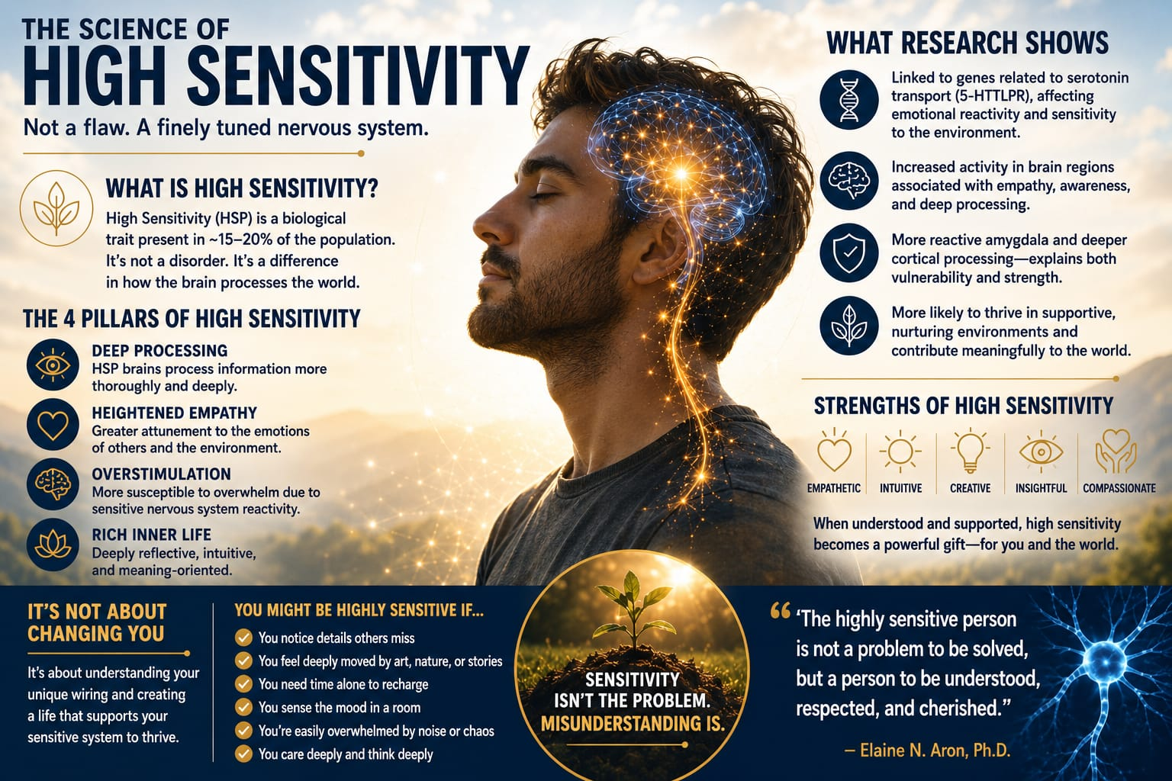
— — —
Chapter 4
The S Word
Scott Barry Kaufman, Ph.D. — HSP, #1 Psychology Podcaster in the World
A lot of men, as soon as they hear the word sensitive and highly sensitive person, they tend to tune it out because sensitive in our culture has been construed to mean something offensive. Sometimes we think of whiny or complaining a lot or very overly sensitive. In fact, it's been used almost as a weapon to hurl at people. So the S word, as we like to call it, really almost is a dirty word. But we'd like to get beyond that stigma.
We would like you to think of it as a genetic trait that you can come to know — that is intended by nature. It's evolved for a purpose. It's something that you can understand. It has no particular impact on you as a man, whether you're masculine or not — has no connotations for that at all. But what we are interested in is you getting past that so you can understand that sensitivity is actually the ability to register, process, and apply information that you've gained from the environment.
Sensitivity does allow us to have more inputs. It gives us more fodder for meaning making. It gives us more fodder for expanding our scope of consciousness. So,we really would be remiss to not talk about sensitivity if we're trying to talk about what are the elements of human potential.

Andy Lightfoot — HSP/HSS, US Army, Railroad Engineer, Police Force, PTSD Survivor
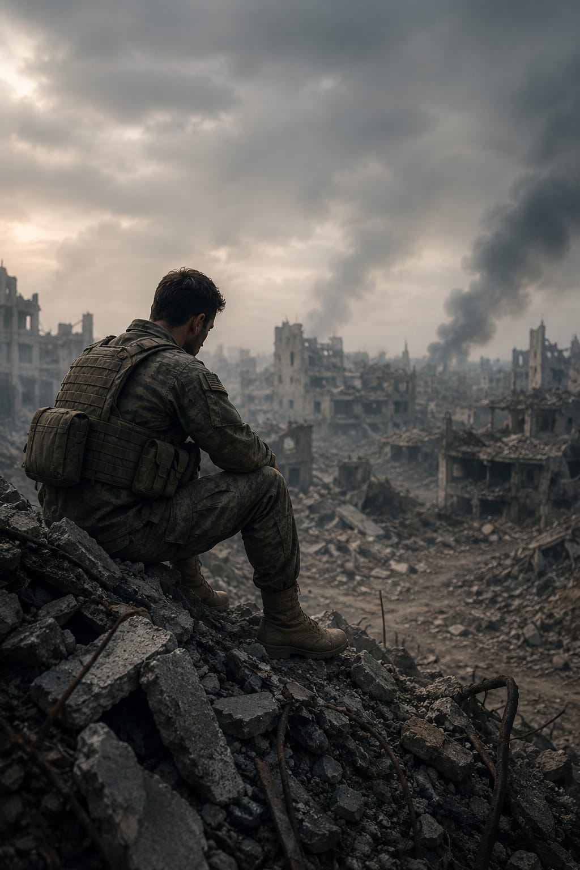
The word sensitive in the mind — that's hard for a man to accept. As far as the high sensitivity, I always believed there was something fundamentally flawed about me at my core, just from feeling things so much. Being in the military, being in law enforcement, being in the railroad than other people. And that was also part of me that I saw as a weakness.

Chapter 5
A Whole, Full Man
Alanis Morissette — 7times Grammy Award winning Singer, Songwriter & Musician
A lot of men — particularly highly sensitive men — have that discernment and that intuition to see where there's a glitch in the field. And in this case, the glitch in the field is that men can only show up as one way. No human can show up as one way. We're complex human beings, complex creatures. I think based on some of the highly sensitive men I've spoken with, the concern and the inquiry really is around: well, what is it to be a whole, full, powerful man in today's world? So let's talk about that.
To be a whole, full man in today's world, there is an inherent invitation by the hunger for attachment and relational correction. For those of us who are attuned to the subtlety of what it is to relate — to step up and talk more and share more and be vulnerable more, thereby being empowered. And the messaging of what a man should be is a dangerous one if we're going to continue to evolve as human beings.
Scott Barry Kaufman, Ph.D.’s #1 Psychology Podcaster in the world Author, Public Speaker
If we can integrate beautiful traits that are on offer among humans — and I consider sensitivity as a beautiful trait on offer — if we can integrate it into the whole person, you're really optimizing human potential that way. Imagine a person who is sensitive and highly sensitive to the needs of others and also has the skills to make that into action and to help and alleviate suffering. Well, that's a dynamic combination, isn't it?
Part of the problem is we have this conceptualization in our society that being strong means not showing emotions. Being strong means fighting people when you disagree with them. When I think having the fodder for sensitivity and being able to harness that power in a disciplined way that is controlled, self-controlled, and directed toward making the world a better place — to me, that's the height of strength.
Greg Johnson — Composer & Co-Producer, Sensitive Men Rising
It can be hard to walk your own path because, traditionally, the world might not want that. Or we might think that the world doesn't want that. But the world needs that. The world needs us to walk our own path, whatever that might be. And say what it is that's in our heart and just put it out there. Let it be out there. It's okay for it to be out there. And hopefully more and more men will know that it's okay.
Brian Torres — A.B.P.P.-HSP Licensed Clinical Psychologist
I see socially on a macrocosmic level that the world is having a falling out with masculinity — the tropes of masculinity, the myths, the toxic masculinity, as we're hearing these things. There's an opportunity for people who are highly sensitive, specifically masculine folks. I can't help but believe there's an opening for a reason. And maybe what the world is wanting is a more reparative experience with men. And I feel like highly sensitive men have an opportunity to make change first.
— — —
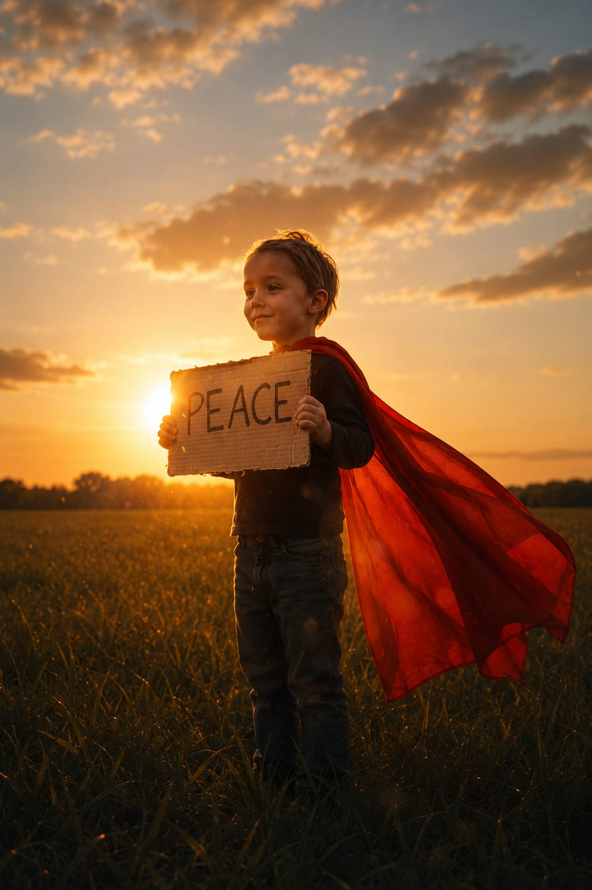

Chapter 6
In His Own Words — Luke Goss & The Man I Am
Luke Goss — HSP Actor, Artist, Author, Director
I'm 53 years old now. I look back and think — I've always known I'm sensitive. I just didn't know it was a trait. That's why this is so important. And also I realized that it then flirts with the ethereal. Sensitivities, empathic energies, almost an assessment of someone's feelings. You watch mannerisms. You get given lots of information of the individual before you. Not wanting to be presumptuous.
A highly sensitive man would have experienced, I think, at moments a lonely walk. Despite his appearance — he could be a tough cop, a fitness instructor, an accountant, a writer — whatever, whatever, whatever. He will have walked through loneliness and misassessment. And I think those are the things. And unfortunately, the recognition comes through feeling somewhat broken or misunderstood through one's own private tears. And it's not a woe is me story.
I just want, like you, to make it easier for future generations to find their compass. Who knows what a man would be and will be if we help him decide for himself.
— — —
A man I am, shaped by life, by choices made. Not all good. Some great. Some I don't remember. But all played their part.
The forging of me. The breaking and the making of me.
And now, oiled, quenched, I see more. I see the wood and I see the trees.
I see my born heart became a man. Sure, little in stature. But a man nonetheless back then. Holding a simple truth wisdom that only a child holds. A heart yet broken or judged.
A heart not yet knowing of the scars handpicked for it, mostly by those who would say they loved it.
A man forged from misunderstandings from those who just couldn't bother.
But now better for it and stronger for it and strangely enough, even more sensitive for it.
Ever proof a sensitive heart can weather the toughest storm without losing its destined design.
That born design we all fight for, that I fight for and win for.
To just be me. To be. To be free.
— — —

Chapter 7
A Legacy of Sensitivity — Dr. Ted Zeff
Dr. Ted Zeff — Pioneer, Author & Advocate for HSP (1947–2019)
I have this trait and I've been dealing with it my whole life. So my first book was called The Highly Sensitive Person's Survival Guide. And people were saying: you write a book about sensitivity, but you're a man. I felt shame because it triggered all the sensitivity of my whole life of being shamed for being sensitive.
Since my last book, The Power of Sensitivity, I have totally transformed myself. I love the fact that I'm a sensitive man. I am proud of it. The more you start accepting your trait, the more confident you're going to become, the more it won't bother you. There's something wrong with them — as opposed to 14, 15 years ago, if someone humiliated me for being sensitive, it would re-stimulate all the humiliation I had for being too sensitive as a boy growing up.
People who are sensitive have very deep, profound dreams. Kind of like from a Jungian perspective, they'd be considered a shaman where they can tune into energy. So you're going to see so many people who are on a spiritual path have the trait of high sensitivity — because you're open to new energy.
Dr. Elaine Aron — Clinical Researcher, Psychologist, Bestselling Author
As many of you are aware, my beloved friend, the cherished author and psychologist Dr. Ted Zeff, left us in 2019. This film is dedicated to him and how he would have loved it. Ted was a tireless advocate for highly sensitive men through his website, videos, and writings, and especially his five books. The Strong Sensitive Boy, Ted wanted to write as a book for highly sensitive men. But publishers warned him no man would buy a book on that subject. He should stick with a book about raising sensitive boys.
Now there are several books for highly sensitive men. Ted was always far ahead of his time on this subject, always our leader. I hope wherever he is, he enjoys watching this film.
Dr. Tracy Cooper Professor Author
Ted Zeff's work continues to live on after him. Even years later, it's still doing good work out there — still changing people's lives. That man championed highly sensitive men his entire life almost. He used to feel fearful of saying that he was a highly sensitive man. But at the end of his life, he said: 'I want to scream it from the rooftops. I'm a highly sensitive man and I'm proud of it.'
Peter Coyote — Narrator
His dedication to helping highly sensitive people, especially sensitive men and boys, is a testament to his deep compassion and commitment to the betterment of humanity.
— — —

Chapter 8
Boy Abunda — Coming From the Poorest Province
Boy Abunda — #1 Talk Show Host, Philippines
I come from the poorest province in the country. And I don't say that in apology. I don't say that to rhapsodize poverty because I have come to terms with that. I also come from a macho area where young gay boys were not allowed. We had to play basketball. We had to build houses. So I have come to terms with being so different. And I'm just so lucky to be talking to all of you.
Will and I have not really engaged each other in the sensitivity realm. But I wanted to experience this and really carry this with me. And whatever happens, this will certainly add a wonderful dimension to who I am and to what I do.
— — —
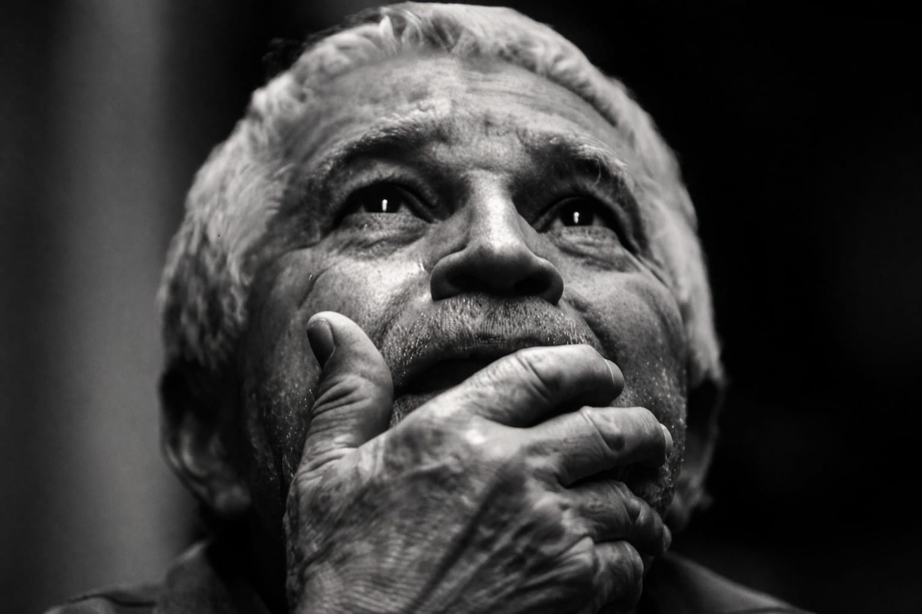
Chapter 9
The Brain Science of High Sensitivity
Will Harper-Sensitive Director
You're probably referring to the renowned research brain scientist, Dr. Bianca Acevedo, who's currently working on more leading-edge brain exploration. She's writing another book about how the different brain regions and networks work together to give rise to high sensitivity in all of its manifestations, including how being highly sensitive and having behavior disorders like ADHD intersect. This is great work. This is needed. This is a giant step forward.
Dr. Bianca Acevedo — Brain Research Scientist
So I know all of you were interested in understanding what we found with respect to high sensitivity and brain connectivity. A lot of people, especially in children, tend to become overstimulated, and the parents and the teachers and doctors may automatically assume that the child has attention deficit hyperactivity disorder, or ADHD. This can be a little bit confusing because the two do overlap in some ways, but they are different and they are different in important ways.
ADHD is a neuropsychiatric disorder with symptoms that include inattention, hyperactivity, and impulsivity. It expresses itself when the person behaves without thinking — they don't necessarily consider the consequences, the long-term outcomes, and especially the impact on others.
Where, on the other hand, people who are highly sensitive show greater responsivity to others, to the environment. They may become overwhelmed, certainly, or negatively aroused, but they are generally highly attentive as opposed to inattentive. Aware and cautious. Even in stressful circumstances, they may be more reflective, cautious, exhibit temperance, and especially in response to others and what they need.

— ——
Chapter 10
High Sensitivity and ADHD
Marc Almodovar — HSP Advocate
I've learned a lot about some of the different issues that men with ADHD deal with. Turns out as men with ADHD, we don't just struggle with focus or struggle with impulsivity, but a lot of men with ADHD are also highly sensitive. We deal with this thing called rejection sensitivity, and there's a variety of things that go on here. And it's really, really critical that we are giving men with ADHD the resources that they need in order to thrive and operate and be confident in society.
When it comes to sensitivity — in my view, it's something that we should embrace. We should always look at ways in which we can put ourselves in a position in which our sensitivity serves us as opposed to works against us. Our work is putting in place boundaries, looking at our people pleasing tendencies, how we can navigate that. But once we have those places figured out, that's when we really, really start to see the benefits. I 100% have seen the benefits of being a sensitive person myself. It's because I put myself in a place where my traits work for me as opposed to working against me.
— — —

Chapter 11
Coping — Finding Your Way Through
Peter Coyote — Narrator
This film has two purposes. First, like its predecessor Sensitive: The Untold Story, it seeks to wake the world up to the truth about the innate trait of high sensitivity as the trait manifests in men and boys. The focus is on the science again, but also the impact of how sensitive males in particular are raised and the various ways they learn to cope.
Coping is much more complicated for them than for sensitive women because sensitive men do not fit the image most cultures maintain of what a real man is.
Andy Lightfoot — HSP/HSS, US Army, Railroad Engineer, Police Force, PTSD Survivor
We were always taught hey, you don't show your emotions. Hey, toughen up. Men don't cry. And that if we feel emotions, there must be something wrong with us. There's a series of years where I just drowned it out with alcohol, drowned it out with anything else to distract my mind off of the pain. Working out at the gym for several hours at a time. That's maladaptive coping.
The perception of being weak or having emotions — this is a challenge for men, because we always got to be seen as strong, stoic. And there's a difference between processing emotion and blocking it. The denial of emotion — there's a huge denial that it even exists. This is a challenge that men struggle to get over.
Now I understand what goes on a little bit better with my own emotions. And so I'm not afraid of them. If I'm going to cry over something, I'll cry for sure. It feels good. And I don't care who sees me. The emotion we feel is part of our system. That's all it is. It's survival-based fuel — a fuel that instantly hits our system and pushes us into safety.
Daniel Miller, Ph.D., LMHC — HSP Professor & Psychotherapist
One of the most helpful strategies for managing strong emotions is being proactive. So trying to have a proactive plan for managing yourself, taking care of yourself, having an active self-care plan, planning ahead — engaging in things like mindfulness, organizing your schedule in a way that works for you.
Taking care of yourself in regards to sleep and nutrition and engaging in things that you enjoy — artistically, in nature, or through exercise. All of those things to just sort of be proactive about maintaining your emotional health.
But then there are going to be things that surprise you and come out of the blue. And when that happens, I think it's most helpful to find acceptance for your emotional response. Don't allow that societal stuff to compound the difficulty by telling you that you shouldn't be having this emotional response because you're a man, that you should suck it up and tamp it down — because that's actually going to make your emotional response bigger.


What we know about emotions is that they never stay static. They always are changing — that's the nature of emotions: motion. If we can recognize that emotions are always going to shift, we can know that whatever we're feeling is going to be temporary. So we just need to take care of it in that moment and then it'll move on.
Chapter 12
The High Sensation Seeker
Will Harper-Sensitive Director
There's a wide range of neurological, biological, environmental, and behavioral differences that make each highly sensitive person unique. In particular, Andy Lightfoot — a sensitive, sincere, and spontaneous character who falls into the 50% group of highly sensitive men that are also high sensation seekers. This trait, as described by clinical psychologist Dr. Marvin Zuckerman, leads individuals to feeling bored easily, thrill-seeking, taking well-considered risks, and constantly seeking out new and novel experiences in life.
Dr. Bianca Acevedo Brain Scientist
This is a great topic. It's important for people to know that they can have both traits. Because it's like the traits are opposite — you can be highly sensitive and still be high sensation seeking.
Dr. Tracy Cooper Professor Author
You can be both a high sensation seeker and a highly sensitive man. Having one foot on the brake and one on the gas is an apt metaphor for the half of highly sensitive people who are high sensation seekers.
The high sensation seeker trait contrasts with the standard highly sensitive trait and can cause internal conflict for highly sensitive men. This dichotomy can also amplify the assertive side of a sensitive man due to fluctuations in testosterone levels — which is another strong genetic trait that's stronger in men than in women. Balancing these two traits can be challenging for men and their relationships until they comprehend and manage this duality.
Dr. Bianca Acevedo Brain Scientist

We love being open and exploring our environments and understanding things, but we must go slowly and measuredly because we're highly sensitive. Another interesting aspect of this research is that it highlights that not all highly sensitive individuals are introverts or shy or socially anxious.
— — —

Chapter 13
The Most Wonderful Thing
Dr. Elaine Aron — Clinical Researcher, Psychologist, Bestselling Author
The most wonderful thing about sensitive men of all is their tremendous empathy. Sensitive people in general are more emotionally responsive and more understanding of other people's situation. But to find that in a man is pretty fabulous — because so often men don't notice subtleties, so they don't even get the emotions that other people are feeling, and they therefore don't have a chance to express empathy or understanding. Very often they just mow right over the other person's feelings.
But sensitive men are much less likely to do that. They're much more likely to notice the emotions, subtle expressions, the subtle movements that tell them that somebody's not feeling so good right now. And just maybe a word would help them to give to others again rather than feeling downhearted.
I've always imagined that sensitive men should come together and talk together about what's happening in their lives. And I imagine this film as a chance for men — sensitive men — to watch other sensitive men and to feel a bond and to know that they are brothers, that they have this thing in common, even though it's completely invisible, that it's there and that they've been dealing with it in their various ways on their own, and that now they don't have to be on their own.
I hope that with this film there'll be lots of support from everyone — from sensitive women, from men who are not as highly sensitive. Everyone will understand better the situation of sensitive men, how much they have to offer, how very much they have to offer.
Dr. Tom Falkenstein HSP Clinical Therapist Author
The research that is currently happening will drive the knowledge forward. That is really important — that this is based in research and that we find out more about it. There are still a lot of psychiatrists and therapists and teachers who don't know about high sensitivity, who are not familiar with the research. And the other thing I think is by doing exactly what we're doing right now — by writing books and by making documentaries and by putting the word out there so that people know about it.
You have to have heard of it. You have to have a concept in order to self-identify with it.
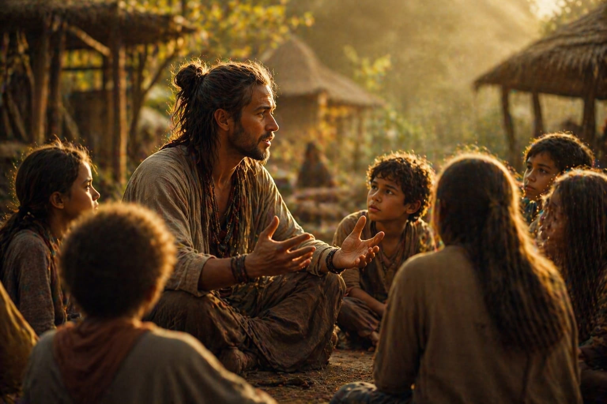
— — —
Closing
The Path Forward
Will Harper-Sensitive Director
So, what Bianca and Tracy made me aware of is that the diverse layers of a highly sensitive man can interact in complex ways, making each highly sensitive person's experience totally unique. So navigating the path of a highly sensitive person is a multifaceted journey influenced by a myriad of personality variables and the environments we navigate. We may exhibit characteristics such as thoughtfulness, empathy, and reflection, all while bearing the conceivable scars of yesterday's trauma — trauma that can shape our adult selves.
Dr. Jed Diamond — Ph.D., Author, Therapist & Men's Specialist
From my experience, many of us men who are sensitive can go through trauma in our families. I know I did. And so the impact of our environment and the world that we live in certainly impacts us. The good news is that through our healing and through recognizing the gift that Elaine and so many others are offering us — men in this case are really being called upon to thrive to the best of the beauty that we're all capable of having.
Peter Coyote — Narrator
We're confident that the ways sensitive men differ from other men could be exactly what the world needs.
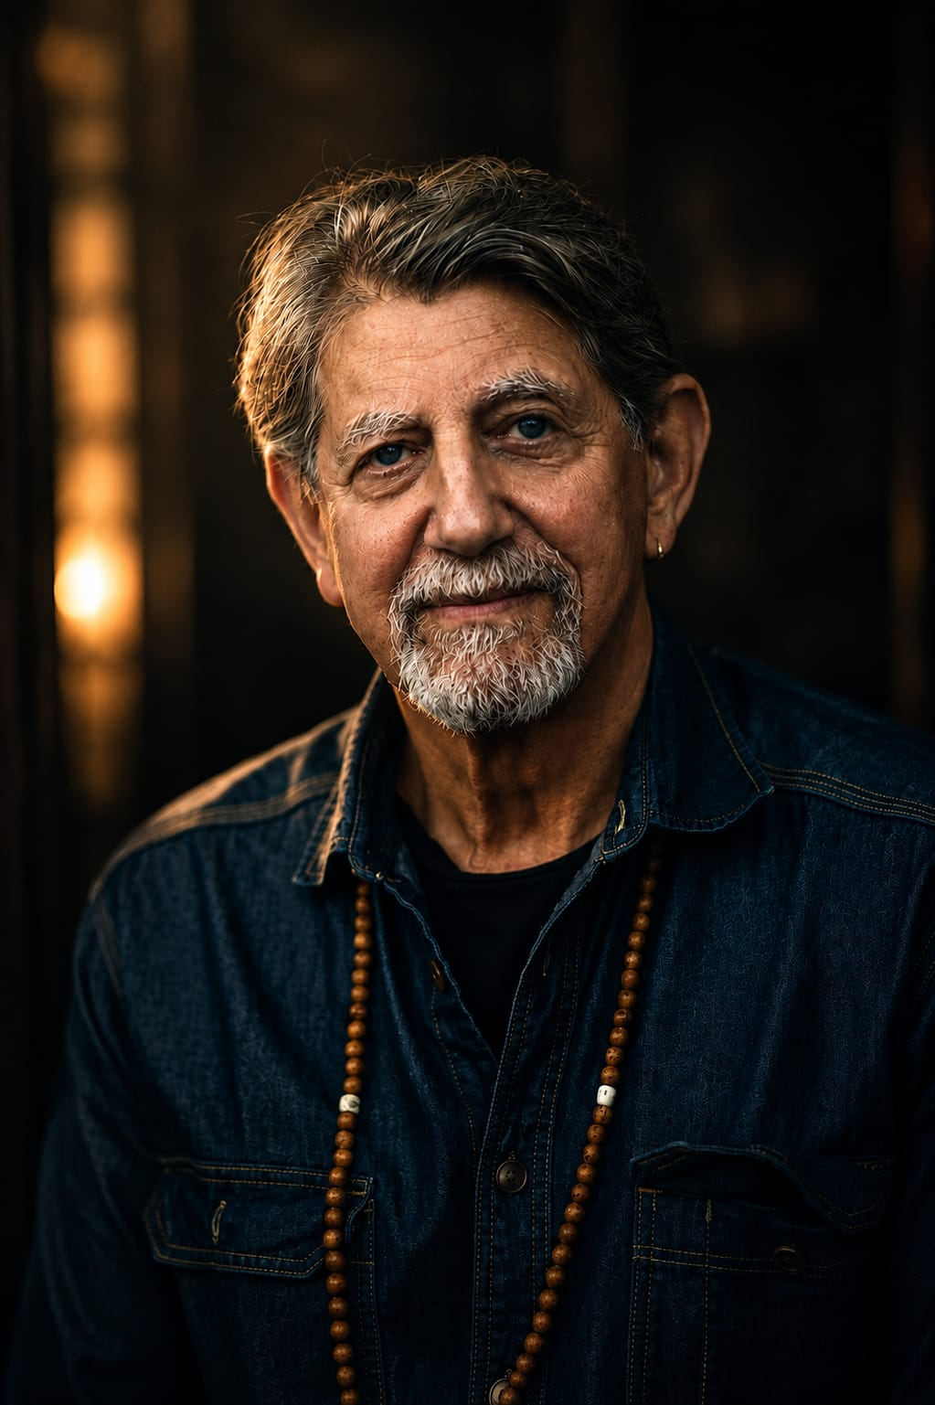
Deep processing of information, empathy, emotional responsiveness, sensitive to subtleties. It is an amazing package, all having evolved so that those who have this trait can see better what is happening around them. And right now, to see what is needed on our planet.

EPISODE II
The Sensitive Child
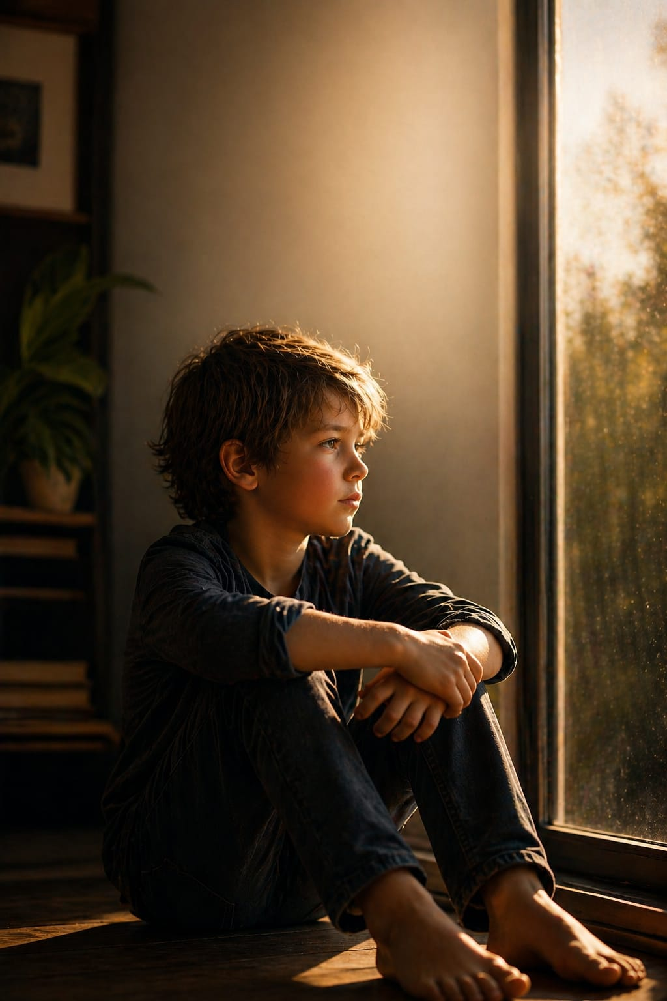
How Boys Are Shaped — and How to Shape Them Better

Table of Contents
Introduction: Differential Susceptibility and the Sensitive Boy
Chapter 8: Growing Up Sensitive — Signs Every Parent Should Know
Chapter 9: Walt's Story — A Mother's Journey
Chapter 10: What Sensitive Boys Need Most
Chapter 11: Boy Abunda — Count Yourself In
Chapter 12: Dr. Michael Pluess — The Ideal Environment
Chapter 13: Dr. Kim Fullerton Nelson — Raising a Sensitive Son
Chapter 14: Soborno Isaac Bari — The Highly Sensitive Boy
Chapter 15: Daniel Miller, Ph.D. — Awareness as Prevention
Chapter 16: Alane Freund — Creating the Great Environment
Chapter 17: Susan Fisher-Crooks — A Legacy for Walt
Chapter 18: Joseph Keon — Surviving Violence, Finding Strength
Chapter 19: Rebecca Taylor Shaw — The Sensitive Boy Who Pushed Back
Chapter 20: Brian Torres — Sensitivity and the LGBTQ+ Community
Chapter 21: Kai Martin — Social Media and the Sensitive Teen
Chapter 22: Tim Jackson — Start at Home
Chapter 23: Greg Johnson — Finding Your Voice
Chapter 24: Dr. Tom Falkenstein — The Message That Changes Everything
Chapter 25: Dr. Tracy Cooper — The Nurturing Environment
Chapter 26: Luke Goss — Ambassadors for Life
Chapter 27: Scott Barry Kaufman — Own It
Chapter 28: Alanis Morissette — Raising Sensitive Sons
Closing: It's Time for a New Chapter

Introduction
Differential Susceptibility and the Sensitive Boy
Peter Coyote — Narrator
You're about to hear a number of stories, a number of histories from grown men about their childhoods, and some stories of sensitive boys that are still unfolding. We're showing you a very wide range of childhoods for a reason. These dramatize what we've been saying about differential susceptibility better than any lecture on the subject. From these, you'll see how much environments matter for sensitive boys, as well as how some sensitive men have risen above tough beginnings. Above all, we hope you will see how much you who are watching matter as you touch the lives of the sensitive boys around you.
Differential susceptibility makes raising a sensitive boy like sculpting a masterpiece. What an opportunity. But that job has a whole new meaning in today's world of unregulated social media and unprecedentedly violent movies and video games aimed at kids. However, fear not. Raising a sensitive boy doesn't mean constantly being on high alert. It just means you need to be aware and prepared to offer gentle guidance, practice unconditional love, and learn to read the signs of your son's sensitivity.
— — —

Chapter 8
Growing Up Sensitive — Signs Every Parent Should Know
Dr. Ted Zeff — Reading the Signs (written by Dr. Elaine Aron)
A highly sensitive child asks deep, thought-provoking questions. Learns better from gentle correction than strong punishment. Uses big words for his or her age. Has a clever sense of humor. Seems very intuitive. Feels things deeply. Notices the distress of others. Considers if it's safe before climbing high. Seems to read your mind. Asks lots of questions. Is a perfectionist.
Will Harper-Sensitive Director
These are a few indicators or signs as read by the late Dr. Ted Zeff and written by Dr. Elaine Aron that may suggest the presence of the highly sensitive trait in children regardless of gender. While this list is not exhaustive, these examples can serve as initial clues for identifying sensitivity in your child. It's important to note that these signs do not offer specific instructions on how to raise a sensitive child, but they can certainly guide you towards a deeper understanding of your child's sensitivity.
Joseph Keon — Author, The Alzheimer's Revolution
Every child is unique and children bring a certain constitution, but also their environment is affecting them in ways that we're not necessarily aware of. We don't know all the ways in which they're being shaped, but we've got to be present. We've got to listen. We've got to watch. We've got to be perceptive and get that feedback and that information and use that to parent effectively — and parent in a way that's sensitive, that's kind, that's aware. And I think that's critical.
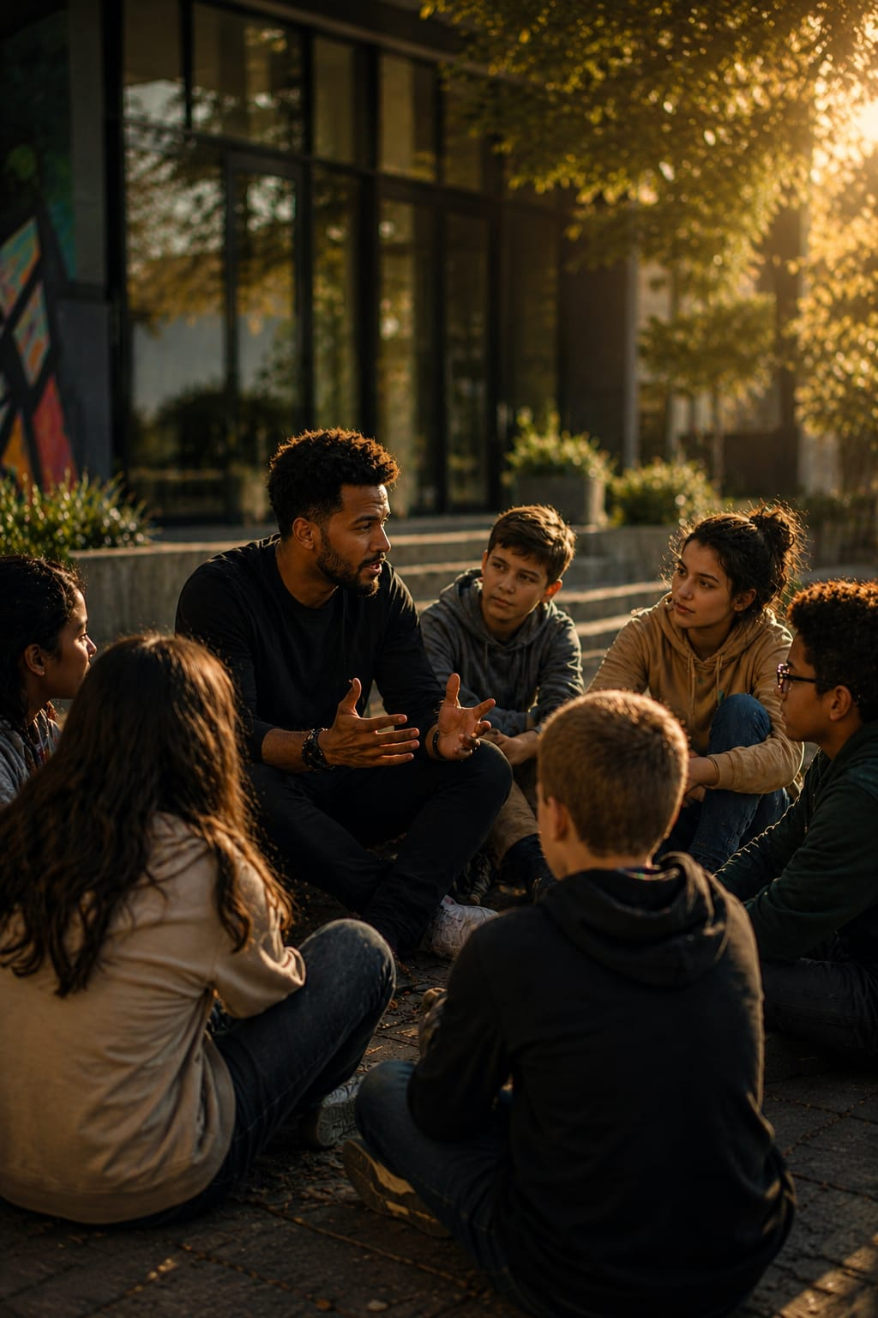
— — —

Chapter 9
Walt's Story — A Mother's Journey
Susan Fisher-Crooks — HSP, Founder of Walt's Waltz
When my son was born, I didn't realize that Walt was a sensitive person. He was born in 1984. Elaine and Arthur's work wasn't even out until 1997. Sometimes it's so easy to miss these subtle signs of a highly sensitive person. We didn't know what these signs meant.
Peter Coyote — Narrator
High sensitivity is so often overlooked because it's so hidden — like an enigmatic presence within the realm of personality. Parents often miss it or misunderstand it. Uncovering the true essence of sensitivity can be an arduous journey, for it defies the simplicity of first impressions.
Susan Fisher-Crooks Founder/President Walt’s Waltz Foundation
When I think back on Walt when he was a baby and when he was a little boy, he was full of emotion. He would cry and cry and cry, and I would try to console him. He didn't like it if someone was looking over his shoulder when he was doing things. If I'd say it's time to put your toys away — I've said it three times — he'd be like, 'You don't have to yell.' And I'd be like, oh my gosh, this is really not yelling. But when I look back at my sons and think about raising highly sensitive men, I think about all the different things that I could have done differently.

Peter Coyote — Narrator
We all have to learn to regulate our emotions, but because highly sensitive people have stronger emotions, there's more to learn.
Susan Fisher-Crooks Founder/President Walt’s Waltz Foundation
My son had a speech impediment and when he went to school, his friend would translate for him, so the kids knew what he said. I didn't realize until he was older — he got made fun of. He was bullied. And I didn't even know that, because he didn't share this with me. That actually was really traumatic for him. But what I think we need to realize is that sometimes something that can become really traumatic may not seem as big or traumatic as the impact it has on a highly sensitive person.
Peter Coyote — Narrator
Studies find that highly sensitive people especially need to focus on five skills: accepting their feelings are real; not being ashamed of them; believing they can cope as well as others do; trusting that bad feelings will not last long; and believing that they can do something about their bad feelings eventually.
Susan Fisher-Crooks Founder/President Walt’s Waltz Foundation
I think about strategies and ways that I could have helped him more and talked to him more. I just feel like for some reason, I didn't talk to him enough. How are you feeling? Why do you think you feel this way? And now that we know about this sensitivity, telling them about this trait is just powerful — because they know who they are. Just simple breathing, and telling them to say to themselves: I'm okay. I'm okay. I'm a sensitive person. It's just who I am.
If you'd see him, he was all muscle, big, handsome man. Could do almost anything. Super bright, humble, and gentle. But also he had a bit of insecurity to himself. And that's what I wish I would have helped him with more — how to feel secure in who he is.
Peter Coyote — Narrator
Highly sensitive boys can indeed have vivid imaginations, and they may find themselves frequently immersed in their inner world — a world that can be both illuminating and dark at the same time. Negative experiences coupled with a lack of coping skills can have a heavy impact on their inner journeys, leaving them overwhelmed.
Susan Fisher-Crooks Founder/President Walt’s Waltz Foundation
People are suffering because they have to hide who they are. Maybe they are in a completely wrong job for who they are. I feel as if Walt was in the worst job for being a highly sensitive person — with all the computer stuff, all the social media, all the micromanaged multitasking. It's just like a strobe light, right, just coming in. And these types of jobs just aren't for the highly sensitive person. Walt was so tired. Over the years he was so tired, because he kept trying to fit himself into this box.
Throughout Walt's life, sometimes there would be events that happened — things others might brush off or blame someone else for. But because of the negative effect, sometimes it just seemed worse. And it was hard to recover. Trauma after trauma after trauma. And then these things build.
Peter Coyote — Narrator
Susan's highly sensitive son, Walt, suffered from treatment-resistant anxiety and depression. After a twenty-year struggle, Walt passed because of suicide. We do not know the rate of suicide among highly sensitive men, although we know that many are struggling as Walt was. We do know that worldwide, men die by suicide two to three times more than women, and it is one of the leading causes of death among young people. The good news is that highly sensitive people benefit more from treatments that work to reduce depression and stress. We just need to see that they get the interventions they need.
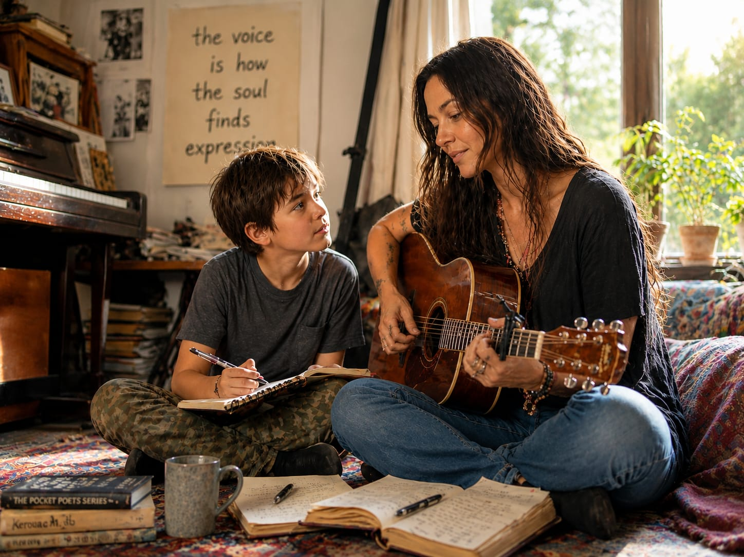
— — —
Chapter 10
What Sensitive Boys Need Most
Daniel Miller, Ph.D., LMHC — HSP Professor & Psychotherapist
So in regards to suicide, I think the findings from my research actually suggest that understanding sensitivity and having an understanding of sensitive identity is one of the primary catalysts to improving mental health and well-being for highly sensitive men. Having awareness — and having awareness early on — of your sensitivity and your highly sensitive identity is a primary force in reducing depression, suicidality, and all of those different things for highly sensitive men. Because having the understanding that this is a scientifically valid way to be a human is very cathartic. It helps highly sensitive men feel a sense of validation. It helps them find community and support. And so all of those things help reduce feelings of depression and therefore thoughts and feelings of suicide and suicidal ideation.
Alane Freund — HSP Consultant & Therapist
The tragic story of Walt breaks my heart. And when you layer trauma onto a difficult environment, there's definitely going to be depression and anxiety. Sometimes it looks like withdrawal or anger, and sometimes it does look like sadness and anxiety. The most important thing to remember is: because of differential susceptibility, stressful environments make a sensitive person feel worse — but good environments make us feel great. So how do we create a great environment for a sensitive young man?
We help them navigate school and peers. And one of the best ways to do that is being sure that there is great mentoring in their lives — that they see other ways to be adult than what is being presented to them in the media and in their environments. Another great preventative for mental illness is spiritual practice. With this kind of prevention and care, we can hold these young men safe — and they will become the men who change the world.

— — —
Chapter 11
Boy Abunda — Count Yourself In
Boy Abunda — #1 Talk Show Host, Philippines
This is part of my narrative. I tell young people who are counted out even before they start their careers. I was told straight to my face that I wouldn't make it in the industry — because I was gay, because I had an accent, because I come from Samar. I was not good looking enough to be on television.
I remember this not with pain anymore, but I talk about these things because I want to tell the young boys and girls out there: when you're counted out, sometimes you don't wait for somebody to count you in. You can count yourself in.
Will Harper-Sensitive Director

After meeting men like Boy Abunda and Dr. Michael Pluess, I now understand without conscious, nurturing guardians, sensitive boys may either break or rise.
Chapter 12
Dr. Michael Pluess — The Ideal Environment
Dr. Michael Pluess — Professor, School of Biological and Behavioural Sciences
Looking back, it's quite funny — because I think as a child I had a different understanding of things than I have now as an adult. As an adult, I look back with my training in psychology and developmental psychology, and I realized that I think my parents did a pretty good job.
I grew up in a very ideal environment for me because I had all the support I needed when I needed it. Sensitive people are particularly impacted by their early environment. If the family-created environment is quite restrictive, that can be actually quite damaging. But also in our own research, we find that if the parenting style is too permissive — where parents just let the child do whatever they want — that is actually not good for sensitive children either. They need guidance and structure, but it shouldn't be too restrictive.
I think it's very important for sensitive children that parents give them opportunities to explore and to follow their interests — because they are very much driven by interests and passions.
— — —

Chapter 13
Dr. Kim Fullerton Nelson — Raising a Sensitive Son
Dr. Kim Fullerton Nelson — ER Physician & Musician
I think about my son who would become almost possessed with the music — whether it was Beethoven's Ninth or Metallica's Master of Puppets. He would just feel it in his body. So I knew early on: this is my sensitive child.
One of his first school experiences, he was very quiet and he was observing everything in the room. The teachers thought that he didn't know how to speak for months. And it was finally a developmental psychologist who said: he's just an observer. He's slow to warm up, but he's taking everything in. And because he's able to observe, he can make all these connections — and that can lead to creativity and a depth to the experience.
All feelings are valid. And that being quiet is not a sign of weakness. It's not necessarily a sign of shyness. It's just observing everything. I also saw how he connected with animals and it was just so beautiful. He was the kind of boy who wouldn't step on ants. He would walk around them. I could just see it. He was taking it all in.
I want him to have his own path, to find beauty in the world through music. And I want him to always know that it's okay to cry. It's okay to be sad. If you see tragic things in the world, it's okay to be overwhelmed and to get away from it too, if you need to. So these are all things that our society doesn't necessarily value. And the highly sensitive people can bring that compassion, that empathy, the creativity, the depth of being able to see the big picture and to make connections between different things.
I just hope that they actually start teaching this early on. This personality trait of sensitivity — it's one in five boys in that kindergarten classroom who is going to be highly sensitive. And there's so much value to it, especially for boys who sometimes have this toxic masculinity in the media that's influencing them. To me, that is not the norm. We need to just get away from that, and the solution is Sensitive Men Rising.
— — —

Chapter 14
Soborno Isaac Bari — The Highly Sensitive Boy
Peter Coyote — Narrator
As knowledge about high sensitivity spreads, we anticipate a new guard of families — people who are forward-thinking, open to change, and possessing a deep understanding of themselves and their kids. As these parents and their children begin to speak up about sensitivity, they'll be the new leaders in this movement to understand the importance of temperament for all of society.
Soborno Isaac Bari — Student, NYU International Math Professor
My name is Soborno Isaac Bari. I am ten years old, and I am studying in eleventh grade at Malvern High School. In June 2024 I will be graduating, and then immediately applying to university. My dream is to get accepted by all eight Ivy Leagues at the age of just twelve. And I am what's known as a highly sensitive boy.
Mr. Harper introduced me to the concept of highly sensitive children. I understood that as being highly identifiable with me — because I felt that the aspects like being noticeable of very small things, processing things highly, always thinking about people's responses very deeply, thinking twice before I spoke, feeling empathy for others, and thinking: how can I make them feel better? And that's how I found out I was a highly sensitive boy.
There was nothing wrong with being highly sensitive. Being different is not a bad thing. I believe it's actually a very positive thing — because thinking deeply about other people and what they say is how you can resolve conflicts and arguments more easily and get to a common peace.
Obviously, it's okay to cry. In fact, I've done it many times. Crying is just one way to let out your anger or your sadness or your joy. Crying isn't something that should be seen as unmanly. It should be seen as something to help you clear out your thoughts, clear out your emotions, and just let it all out.
Peter Coyote — Narrator
Driven by his benevolent nature, Soborno embarked on a remarkable journey. He poured his thoughts and emotions into writing, penning his first published book. This book was intended as a powerful defense for those who were suffering, a testament to his unwavering commitment to protect the voiceless and stand up against injustice.
Soborno Isaac Bari — Student, NYU International Math Professor
When I wrote The Love, I didn't use the best language because I was only six years old. I didn't have the widest vocabulary. But I personally believe that I sent a pretty good message about having empathy and not hating others because of what they believe and what they feel, and how we can educate others about empathy.
I don't believe that you need a high IQ to have empathy or a sense of compassion. I believe that highly sensitive children and IQ have no relation.
I personally believe I'm living in a great environment. I don't hear the same views over and over, and I don't hear hateful things from my family at all. If everything you see is hateful and everything you process is also hateful, you yourself will grow up to be just like your environment.
I believe my family has been a great influence on me. They have cared for me so much, and I love them so much — because they've always helped me throughout my challenges in life. And whenever I have a problem, I can just tell them and they'll give me a reasonable solution I would have never thought of before.
— — —
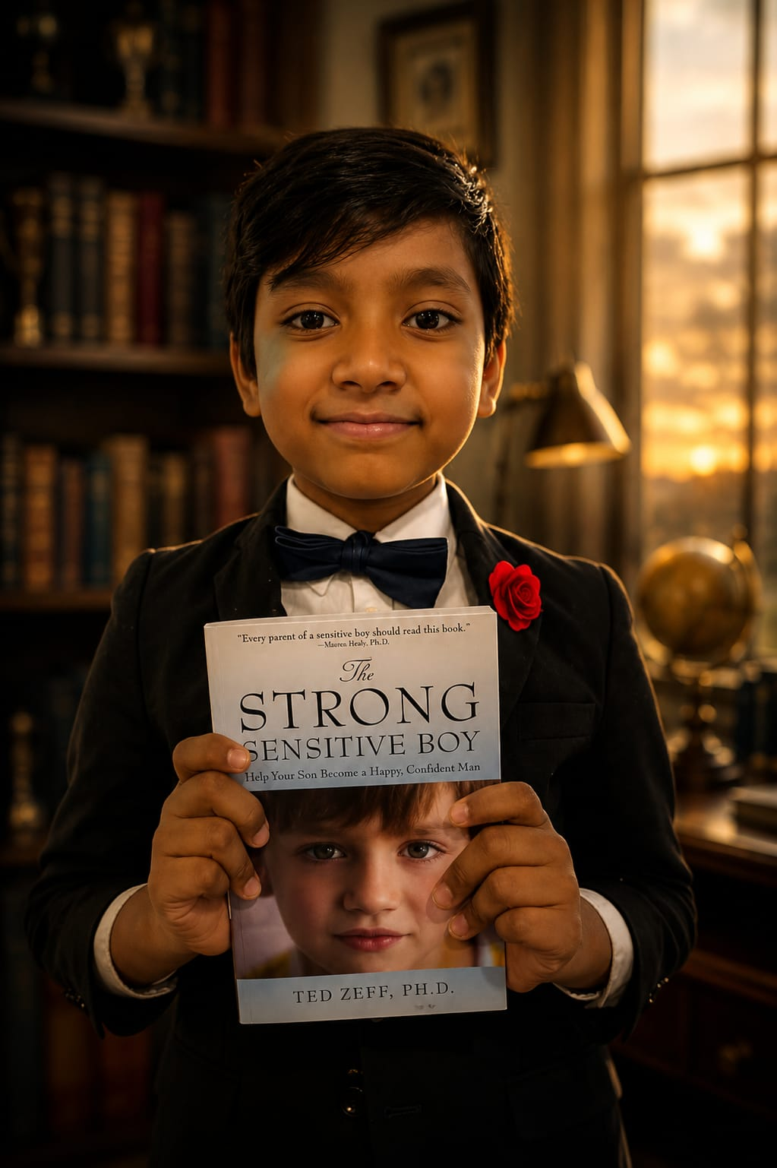
Chapter 15
Dr. Elaine Aron & Tim Jackson — Family Is Everything
Dr. Elaine Aron — Clinical Researcher, Psychologist, Bestselling Author
You keep bringing it back to the family every time. But I think it's so right. I've just had this flash of family members watching this film and talking about it. I would hope so too.
Tim Jackson — Retired Comedian
We're so far to the right and to the left that we forget about the basic things. We talk about teaching our kids to be able to come out into society and deal with the early teenage years where your peers are more important than your parents. So that starts with someone teaching the ground rules for their kids. But we need a fundamental realization in each home to start guiding us that way. It has to be a collective thing — because we can't stop bullying in schools, but we can start at the primary level, the grassroots level, in your house. That's where it needs to go right now because it's such a big battle.
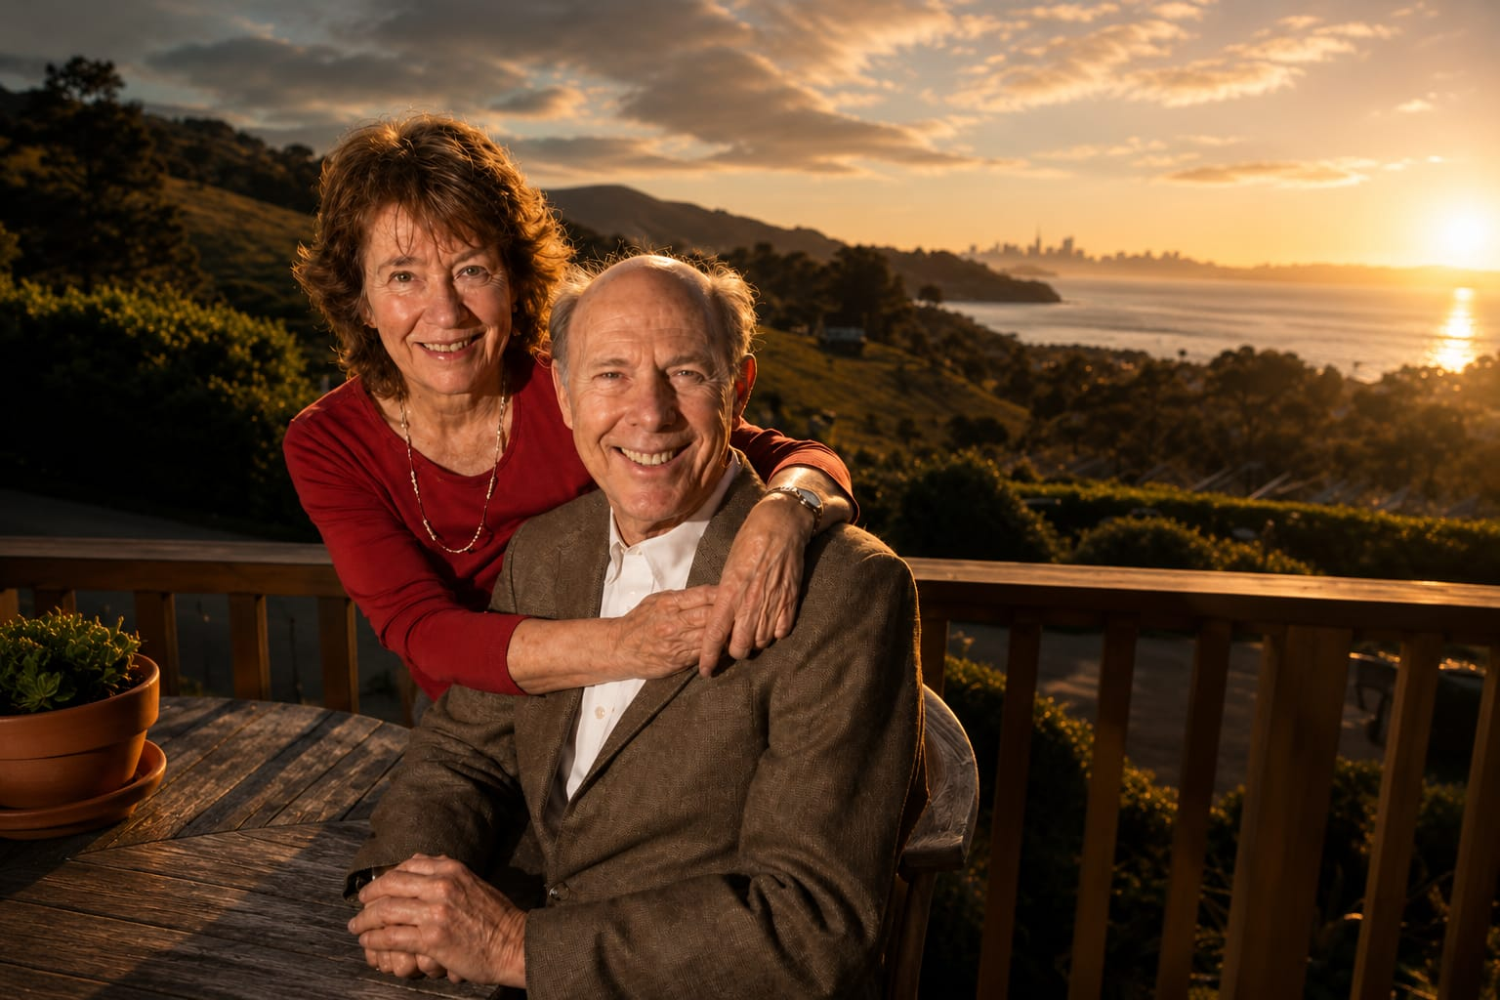
— — —

Chapter 16
Kai Martin — Social Media and the Sensitive Teen
Will Harper-Sensitive Director
Family really, really does matter. As a highly sensitive baby boomer, the battle growing up for me was completely different. I relied heavily on communication from my mom due to limited outlets. Today, with the onslaught of social media and peer dominance as key players of communication, it's a force to be reckoned with, especially in this digital age. I call it social media susceptibility. This phenomenon seems to be greatly impacting teens. Case in point — sensitive boys.
Kai Martin — Therapist
It's become even more challenging to raise children in this day and age with social media and peer pressure. I think it's important for parents to be there. When kids are left alone, there are so many influences. They start to form their own opinions. And when you're being criticized for having these sensitivities, a lot of people flip it and start acting out. They want to fit in. So even if they're sensitive and they don't want to do something, sometimes they'll still go along with it because they don't want to be seen as weak.
With my son, we just talk about a lot of things. He tells me almost more than I need to know. But I appreciate that he feels open. Just reminding these kids that it's a healthy thing to have empathy and to care about other people — and letting them know it was a positive thing to be sensitive and even emotional about things. Learning to have those boundaries is really important too.
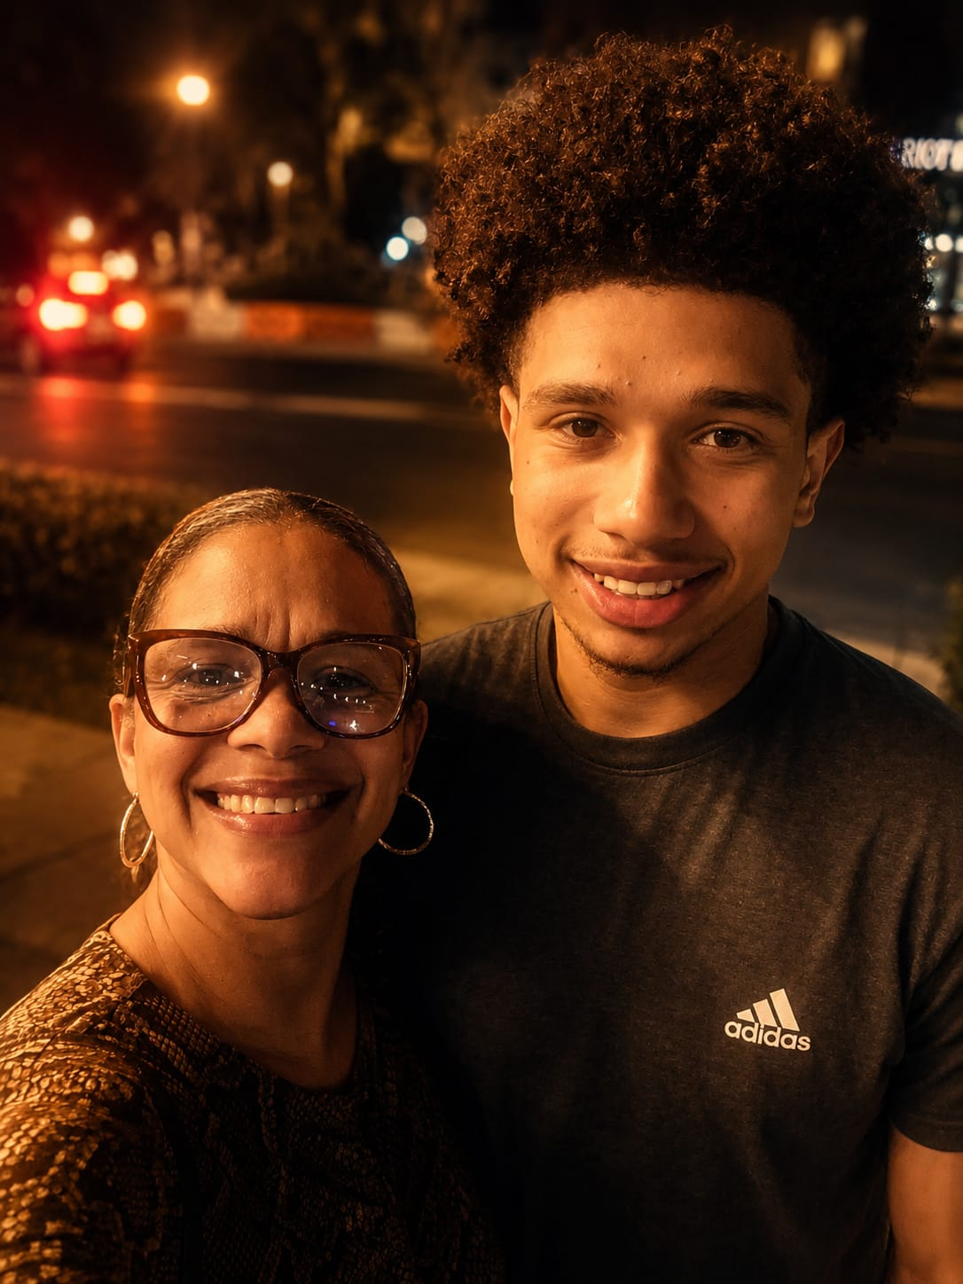
— — —

Chapter 17
Luke Goss — Ambassadors for Life
Luke Goss — Actor, Artist, Author, Director
I think the next step is to encourage awareness. I know this because I've mentioned it to people who don't know those three letters — HSP. That's the responsibility. That's what's next.
And I think we have to be great ambassadors for the rest of our lives, giving courage and encouragement. We've got to keep giving people relief. There's one reason for this: traits should not be overlooked.
My grandfather was a healer. My mother was a peaceful woman — a loving woman, unbelievably proud of her sensitive two boys. But not all men and women start with that. Grandfathers, fathers, mothers, guardians are our teachers. And their teachers are their previous teachers, the same as ours. We are only in the hands of wisdom if we were in the hands of right within our teachers. And once the hardships of life are looked at as lessons of life — without resentment, as opportunities to grow — we'll become better versions of ourselves. And only a sensitive mind and a patient mind can look upon these without fury.
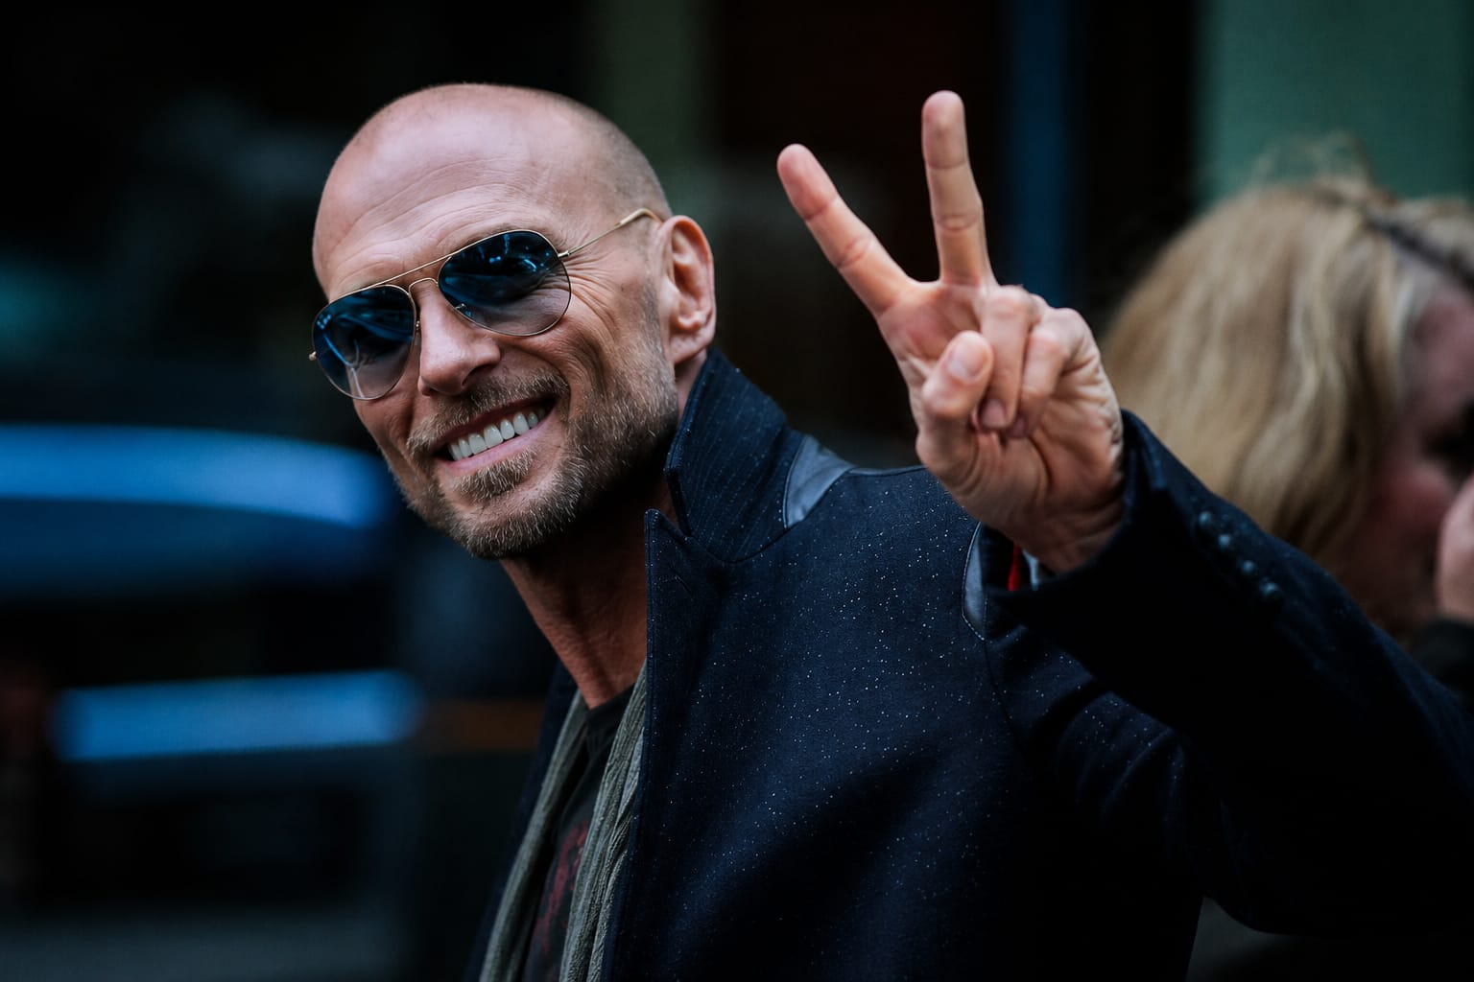
— — —

Chapter 18
Rebecca Taylor Shaw — The Sensitive Boy Who Pushed Back
Will Harper-Sensitive Director
Highly sensitive kids face a tough enough time growing up in today's world. It's filled with toxic challenges, tough situations, and tempting pitfalls at every turn. On top of this, they also encounter teachers and parents who just may not know how to nurture their sensitivity.
Rebecca Taylor Shaw — HSP Certified Hypnotherapist, Charleston, SC
My son is highly sensitive. He's twenty-one years old now. But as a boy, he was — can I say this? Hell on wheels. He was obstinate, extremely willful, and in school he was the kid that would not do what he was told or talk back. But what helped was I was really diving deep into studying oppositional behavior, and I was also seeing that the times when he would act out the most were when the energy of an adult in the room was angry, stressed, or anxious.
He had this one teacher in third grade who had a military background, but her nature, her demeanor was so even-keel, and that kid was easy all year long. Then in the next year, he had this teacher that yelled quite a bit, and that's when he was getting in trouble. So he's a highly sensitive kid — he's feeling that energy of someone yelling.
So if you have a child who is having behavioral problems, especially a boy, don't default into 'He's a sociopath' or 'He's not empathetic.' I'd be looking at the triggers and looking to see: is this child acting up when the energy and emotions around him is chaotic or stressful?
— — —
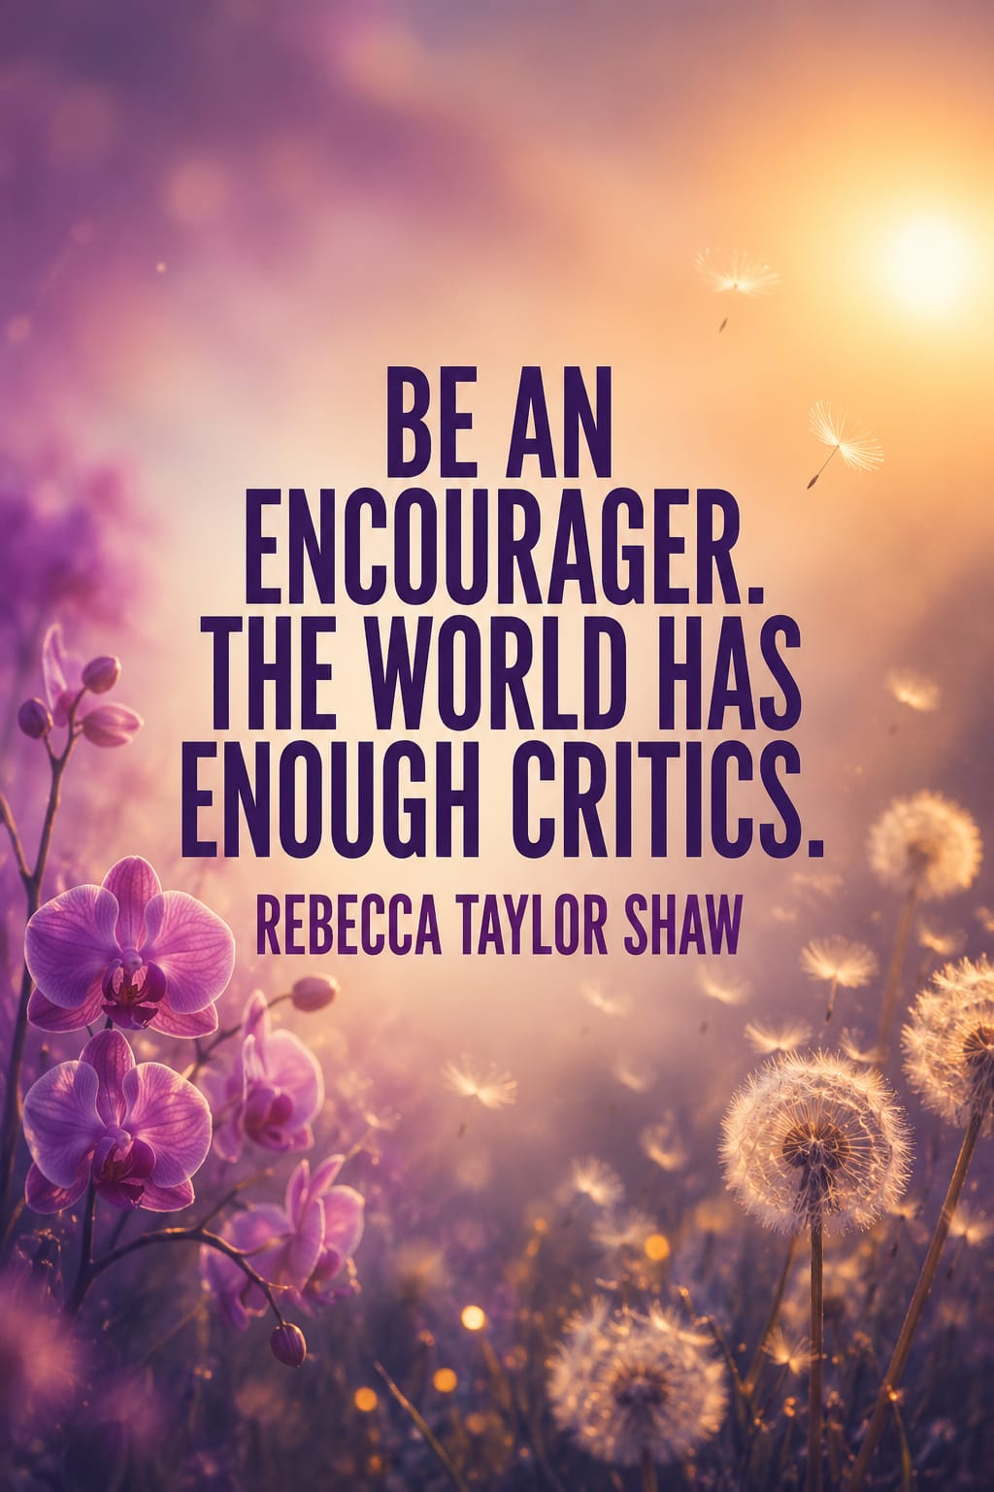
Chapter 19
Brian Torres — Sensitivity and the LGBTQ+ Community
Brian Torres, A.B.P.P.-HSP — Licensed Clinical Psychologist
I think a lot of qualities that are deemed sensitive are things that we grow up hating about ourselves. I know that was the case for me — for sure.
I grew up in an environment that wasn't very affirming. At four years old, I remember experiences of things that are more sensitive were deemed as indicative of something else beyond sensitivity. For me, sensitivity and sexuality got conflated at a really young age. They were mixed up in a way that I thought was really damaging.
Being a really sensitive kid, I was really drawn to the arts — and in my household, boys didn't do art. Boys played sports. My dad literally encouraged people in my life to take art away from me, and I was kind of thrust into really aggressive things like boxing and tackle football. I mean, clearly they didn't stick and weren't things I was interested in. But that's how we, quote unquote, 'manned me up.' Look how that worked out.
I like to think a lot about the highly sensitive community and the intersections with the LGBTQ+ community. It's actually what I specialize in. Specifically for men, I think that LGBTQ+ people are very sensitive to the messages that they don't belong, that they're stigmatized or marginalized in some way. And I just feel really deeply and love working with people to uncover those things and to heal from them.
What I love seeing right now is that this concept of the trait is getting more and more attention. I just feel like the building of awareness is the key — I'm hoping that bleeds over into more parents taking an active interest in what it means to be a highly sensitive child and maybe save their kids from some of the shame that can come with living in a world that's not geared towards highly sensitive people.
A lot of the work I do with highly sensitive men is: let's comb through those memories and then reframe them. Let's reframe the past. Because we can't give you your childhood over — but what we can do is have you go back and just reconceptualize the whole thing with this new lens. That wasn't that something was wrong with me. It was just I had this temperament that was so particular that no one really knew about, and it meant that I didn't get certain things that I needed. How do we grieve the things that you didn't get — and how now as an adult do we give those to you and that child?

— — —

Chapter 20
Greg Johnson — Finding Your Voice
Greg Johnson — Composer & Pianist
I'm Greg Johnson — composer and a highly sensitive Black man. I find that the subtleties of sensitivity are something I'm aware of constantly. Everywhere I look, I feel all the interludes, all the movement, all of the layers of emotions that move in and out of every interaction, daily interactions between people.
I feel them deeply. And I find that converting that sense into music — into compositions — has been the way for me to function in life, to feel like I had a purpose.
Even when I was growing up, I knew that I was that highly sensitive boy. It took me many years before I felt like: hey, it's okay for me to be me, for me to express myself. Fortunately, my mother embraced and nurtured my temperament trait, which ultimately made me feel safe. It sorts of gave me permission to unlock my sensitivity — and then I found my voice.

Will Harper-Sensitive Director
I hear you, Greg, and what a beautiful note. My sensitive mother recently gave me some life-changing advice. She told me to stand up, open the door, and know that I love you. It really hit me — that taking a moment to stop, look around, and listen can lead us to discover the strength in our passions through acceptance. Moms. What a gift.
— — —
Chapter 21
Dr. Tom Falkenstein — The Message That Changes Everything
Dr. Tom Falkenstein — Licensed Clinical Psychologist & Author
I can refer to the interviews I did for my book. I interviewed about twenty-five men who were all highly sensitive, and what some of them described was how important it was for them to feel accepted by their parents. And at the same time, how important the message was that their sensitivity is nothing to be ashamed about. It's not a fault. It's not a problem.
I think it's important not to label children very early on. That is also what Elaine Aron says — there are other ways to talk about it. You can talk about sensitivity in a different way. You don't need to label the child straight away. Give messages that it's okay — and maybe even talk about your own sensitivity if the parent is sensitive. But at the same time, not to label a child maybe too early.
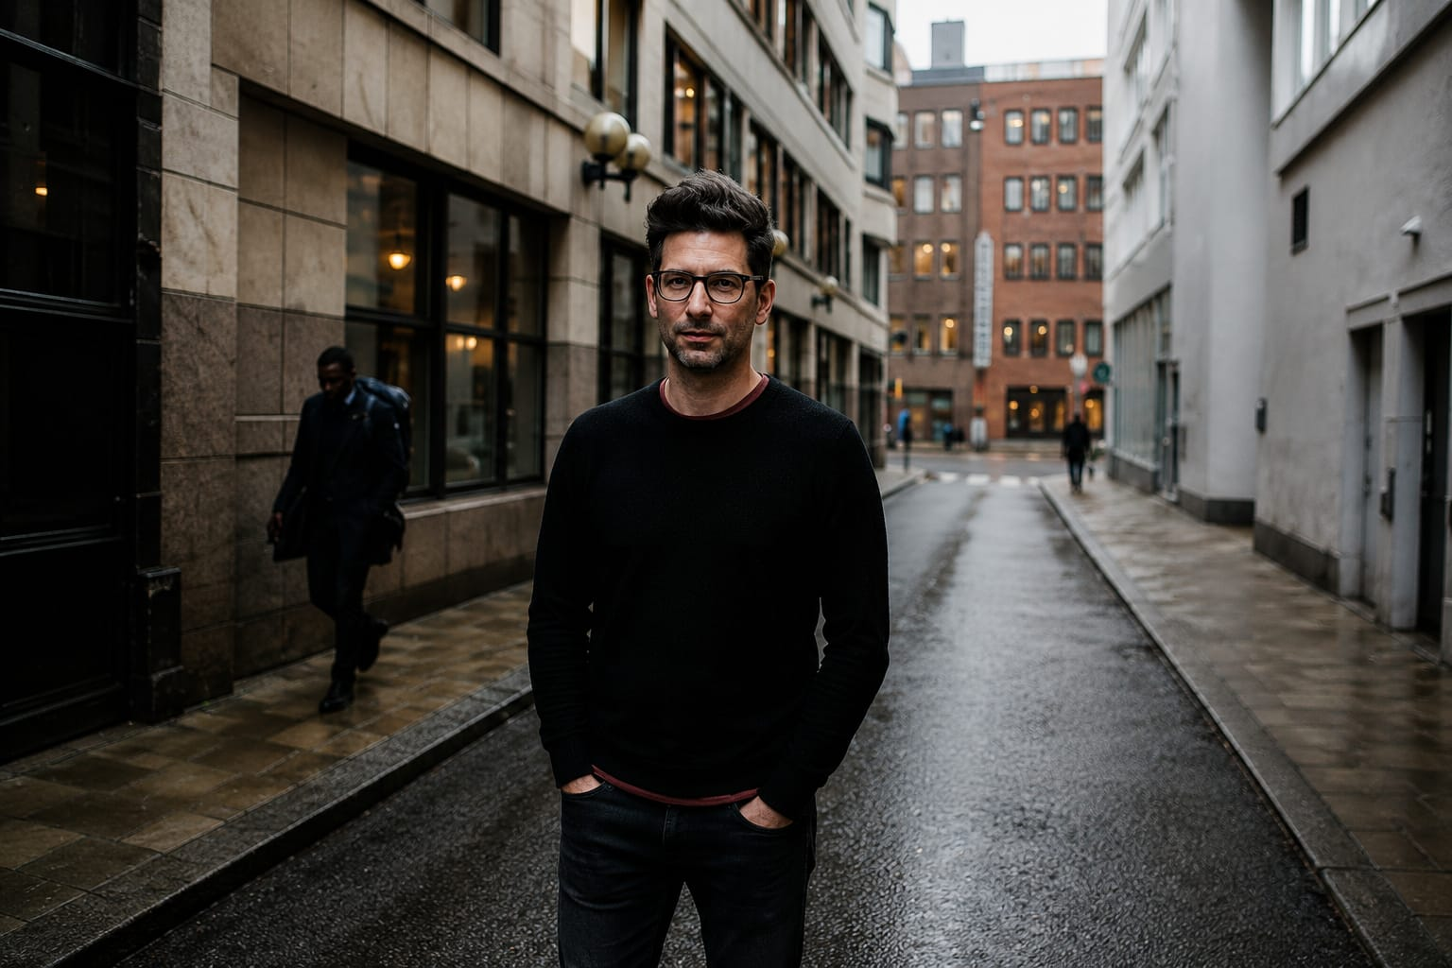
— — —

Chapter 22
Scott Barry Kaufman — Own It
Scott Barry Kaufman, Ph.D. — HSP, #1 Psychology Podcaster in the World
Acceptance is one of the biggest things you could have. People who are highly sensitive and have not accepted that part of themselves — maybe because they've been told their whole life that that's not a good way to be — can develop shame for a potential superpower. Imagine if Superman developed shame for his capacity to fly and save lives. Superman wouldn't have saved a lot of lives, right? So look — there's a great superpower within all of us of sensitivity.
How are you wielding that power? Are you wielding it in a passive way, where you let the universe come to you and you feel hopeless? Or do you wield it in a way where you've taken control of your life and you are the active imparter of your sensitivity in a thoughtful, mindful manner? That's all the difference in the world between feeling hopeless and feeling hopeful.
I was really young. I definitely was a late bloomer academically. I wasn't predicted to go to college. I had a learning disability that made it very hard for me to process things in real time. I was super sensitive to people's expectations of me, which were low as a kid. Not only were people's expectations low of me, but I was highly sensitive to it.
My mom wrote a letter to my teachers when I was three years old, saying: my son is the most creative kid you'll ever see. But sometimes very well-meaning attempts at coddling can really inhibit people's potential.
I was in special education and a teacher took me aside and said: what are you still doing here? And I was like — yeah. What am I still doing here? Good question.
I am in the highly, highly, highly sensitive bracket — but I have worked on myself for so many years where I am no longer an emotional mess. I am proud of the work I have put in. I want people to know that they can change. But it does take inner work. It's not all about making sure everyone around you accommodates you. You have to own it. I'm highly sensitive. Own it. And put in the work to really figure out how you want to show up in this world with that sensitivity.
It's beautiful how much we can differ from each other — and that we can come together and utilize each other's strengths to make a bigger whole that is much, much bigger than the sum of its parts.
Oprah Winfrey — introducing Scott Barry Kaufman
Get ready! I'm inviting you to join our special live stream event. The Life You Want class is going to feature special guest Dr. Scott Barry Kaufman. He is a cognitive scientist and humanistic psychologist. He is the founder of the Center for Human Potential, and he is a professor at Columbia University. He teaches one of the more popular courses there called The Science of Living Well. And by the way, he's authored over ten books and hosts the number one psychology podcast in the world — The Psychology Podcast.
— — —
Chapter 23
Dr. Tracy Cooper — The Nurturing Environment
Dr. Tracy Cooper, Ph.D. — HSP Author, Educator & Consultant
Really one of the most fundamental ways that you can support a highly sensitive child — a highly sensitive boy — is to provide that nurturing, accepting environment. Because we do register more easily everything in the environment. When we are shamed or made to feel guilty or made to feel bad about ourselves in some way, that hits us more deeply for a longer and more profound effect over time. So supporting your child and not expecting him to conform to some other standard — that's a hard thing for all parents. I'm a parent, and I know this for a fact.
So many of us come from families that had traumatic backgrounds. We had traumatic childhoods. We grow up, we get married, we have children of our own, and we don't want to pass those same things on to our kids.
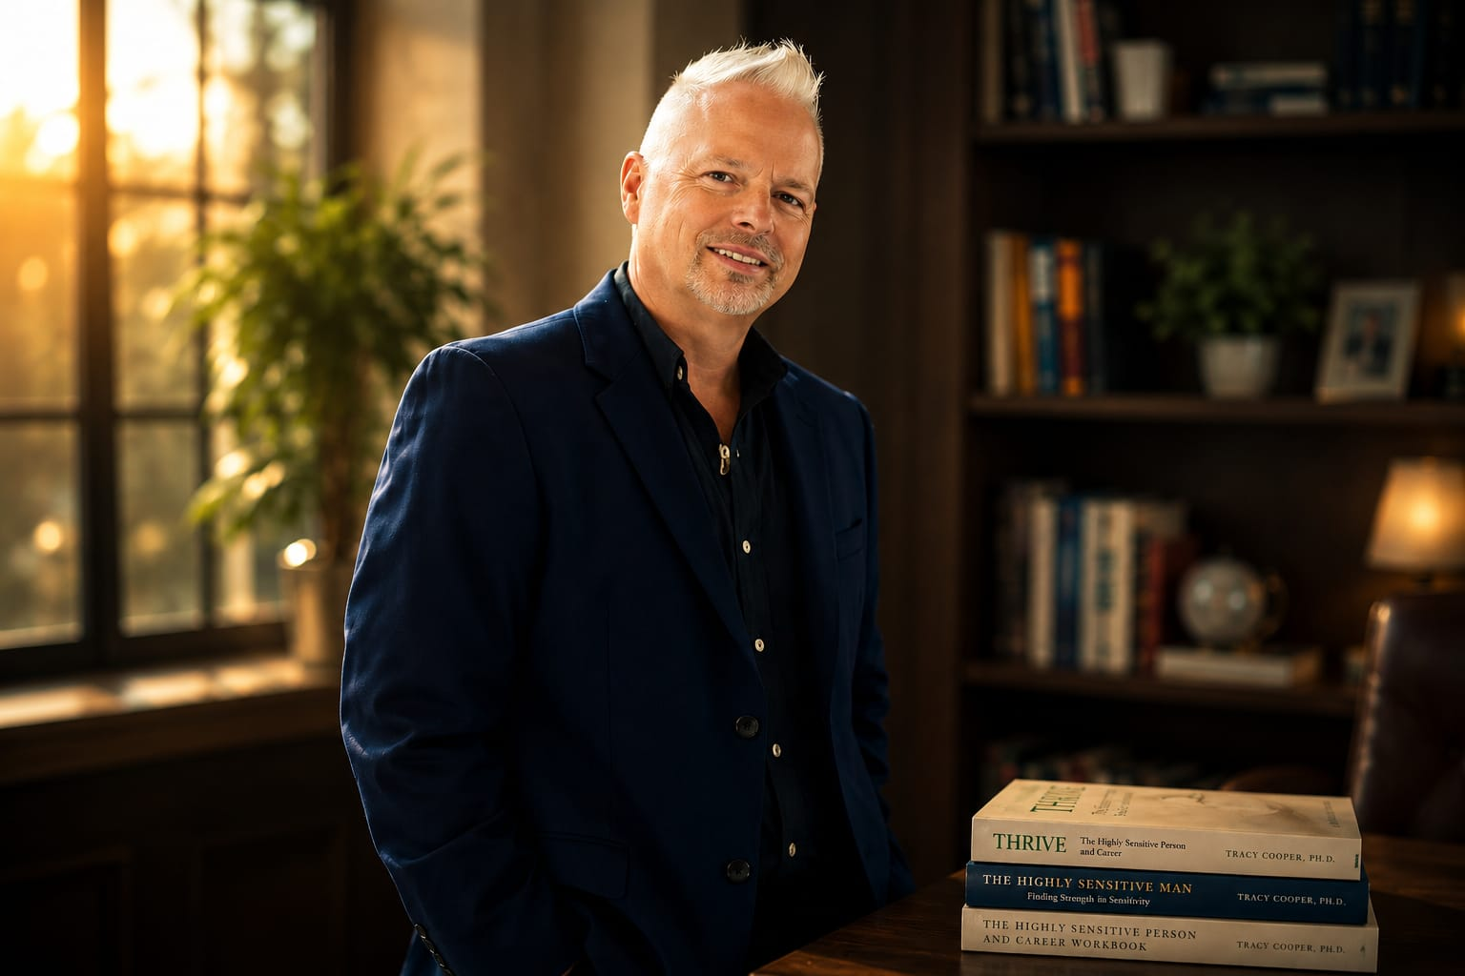
— — —

Chapter 24
Joseph Keon — Surviving Violence, Finding Strength
Joseph Keon — Author, The Alzheimer's Revolution
My father had very strong feelings about who I should be early on in my life. He wanted me to play Little League, to stand out in the field, to rub shoulders with the other dads. And I said, 'Well, I don't want to play Little League. That's not what I want to do, and I'm not going to do it for you.' And it just infuriated him. And so he told me I was no longer his son. My father was physically violent.
Peter Coyote — Narrator
Watching, listening, and observing before reacting is a crucial aspect of survival for anyone, but especially for highly sensitive individuals. By carefully observing their surroundings, listening to verbal and non-verbal cues, and taking the time to process information before reacting, highly sensitive boys often gather valuable insights about their environment and use them to make more strategic responses.
Joseph Keon — Author, The Alzheimer's Revolution
I grew up in a household of violence, and that created an environment in which I was frightened. I was anxious, and I was trying to predict what the environment portended in the next hours, days, weeks. As a coping mechanism, I became a student of my father. I would watch him carefully. I would study the way he spoke. I would listen for changes in the tone of his voice.
Anything that could help me forecast what was coming in the near future and thereby potentially protect myself was what I was interested in. And I think that experience also really helped me in becoming increasingly sensitive as a man in the world — because I learned to pay attention to really subtle cues so I could read people better. And as I developed relationships with people and started going into business, I was much more able to read what people were feeling who were sitting across from me. And that really worked to my advantage as well.
I thirsted for somebody to teach me how to be a man in the world, but there was nobody around to do that. So when I started dating girls, I ended up very fortunately having role models — people who were successful in their own right, but humble. They were generous with their knowledge, with their wisdom, with their time and their resources. And I felt safe with them. I could learn from them. I could study them and model them. And so that helped me shape myself into the person I wanted to become in the world.
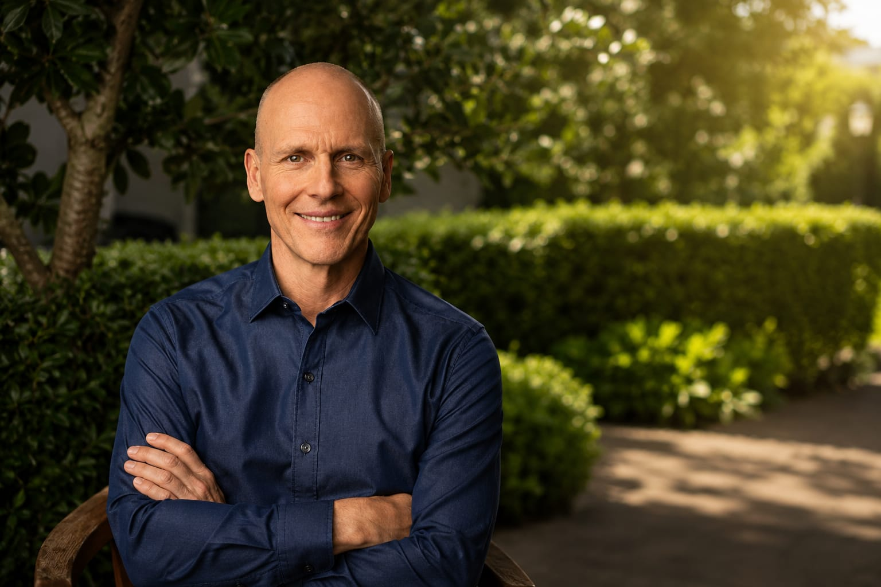
— — —

Chapter 25
Tom Falkenstein & Luke Goss — Men Who Model Sensitivity
Dr. Tom Falkenstein — Clinical Therapist & Author
As we live our lives, we need to be a role model in a way. It's about destigmatizing feelings, about destigmatizing sensitivity. It's about showing the children we have in our lives — whether they are our own children or maybe children of friends — that it's okay for men to be emotional and sensitive and strong. There's a variety in what it means to be a man. And I think that is what we can do.
Luke Goss — Actor, Artist, Author, Director
At least some scientific and artistic combinations are finally coming together. So I think it's something that is an asset with this gathering. We're the beginners of this and everyone's going to have their flavors. And I think that faceted view of all of us presented beautifully and fearlessly — and it's very important that we stand up and do nothing more than let each person radiate their excellence. That in itself is going to be a fun part. I want to be in that circus.
— — —

Chapter 26
Alanis Morissette — Raising Sensitive Sons
Alanis Morissette — 7times Grammy Award winning Singer, Songwriter & Musician
I think as far back as three years old, I remember wanting to be a mom.
Will Harper-Sensitive Director
Hi, Alanis. How many years ago has it been?
Alanis Morissette-7time Grammy Award Winning Singer, Songwriter Musician
Good question. So my son Ever was three. So it's been a good nine-ish years since we sat together, Will. Here we are with Ever nine years later — just really thriving and very, very bright.
Ever sees this world through a lens that is exciting for me because there's an openness, there's a discernment, there's an intuition. There's this sense of commitment on his part to self-expression that is just wildly inspiring to be around. There's a generosity and a conscientiousness that I see as being ubiquitous with highly sensitive people and highly sensitive men.
My two sons, Ever and Winter, are both highly sensitive, and there is an ease of connection between us. We can finish each other's sentences. I have a general intuitive sense of where they're going. So there is a heightened attunement that I feel I can offer them that includes the emotionality and the artistic ideas and the expression and the rapture and the sensuality and the attention to minor details.
The overarching message that I like to think I'm offering my two boys, who are highly sensitive, is that their wholeness is an honor for me to uphold. Their sensitivity, their ideas, their movement, their somatic expression — this whole being is what I feel responsible to hold and to uplift and to remind of its beauty. And that they don't all have to look one way to qualify as a standup gentleman.
I remember when Ever was quite young, he was in the living room, having a lot of feelings like sadness and some anger, and it was quite beautiful. I said, 'Do you want to go in, talk to different parts or...' And he said, 'Mom, I don't want to go in.' And I said, 'I'm going to go in with you though. You're not alone. I'll be right there.' So then we went in a little bit. The idea of creating a safe space for HSPs to delve into this interiority — there's a general space-giving and honoring and understanding around what it is to be a highly sensitive person.
Peter Coyote — Narrator
Alanis's journey of self-discovery was not an easy one, but it led her to a place of authenticity and strength. She now stands tall, unafraid to show the world her true colors, proving that embracing her sensitivity was a powerful choice — a choice that came after a painful walk down the dead-end street of avoidance.

Alanis Morissette-7time Grammy Award Winning Singer, Songwriter Musician
Oh, the false self-that’s created around a highly sensitive temperament to survive in the world is like... It's devastating to even think about it. It's just not whole.
The false self that I constructed — I'm an INFJ on the Myers-Briggs, but I was pretending to be extroverted. I was pretending to be a non-HSP. I was drinking my way to being a non-HSP. I was working my hardest to not look soft, even as a woman. The pervasive message is that who you are somehow is not allowed. And who came up with this? Who came up with this lie of limitation and reduction?
It's a warrior mode that one must be in to fly in the face of cultural expectations — whether it's around gender, parenting, education, medicine, politics, all of it. I want to be in the hands of a highly sensitive person when I'm in the pay dirt of deep inner work. Not a big surprise that I'm surrounded by HSPs.
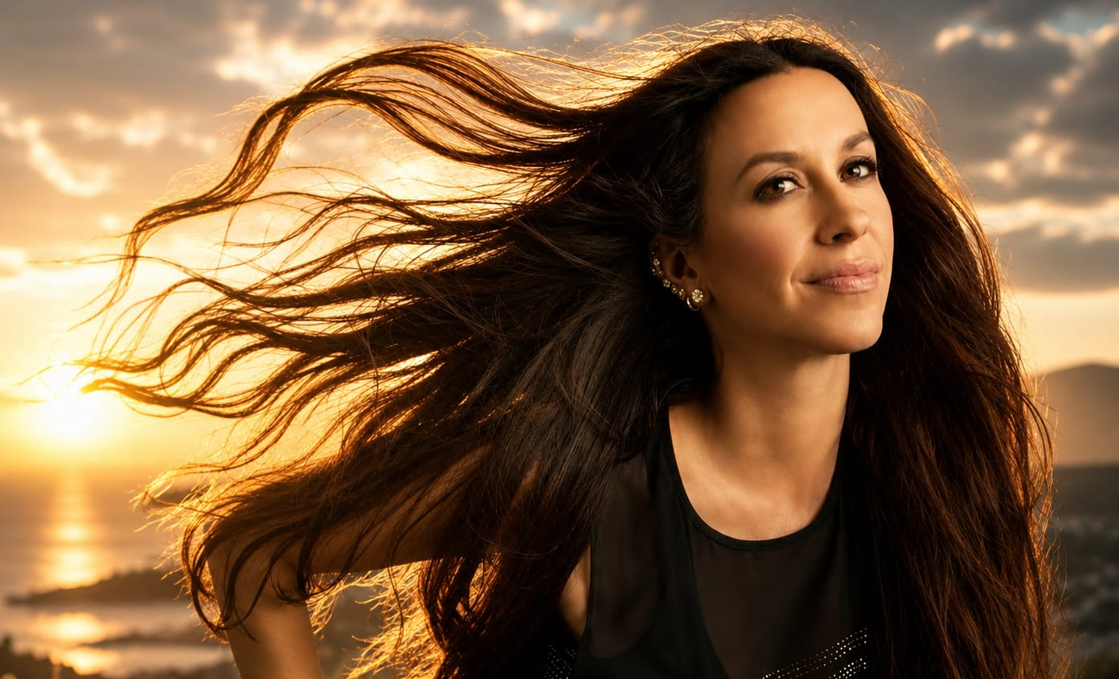
— — —

Closing
It's Time for a New Chapter
Peter Coyote — Narrator
Deep processing of information. Empathy. Emotional responsiveness. Sensitive to subtleties. It is an amazing package — all having evolved so that those who have this trait can see better what is happening around them. And right now, to see what is needed on our planet. The minority sees it better, feels it more. And the majority can listen to the minority and make the needed happen. It is a beautiful partnership. How it is meant to be. So, at the end of the day — what will you do to shift the paradigm?
It's time for a new chapter, isn't it?
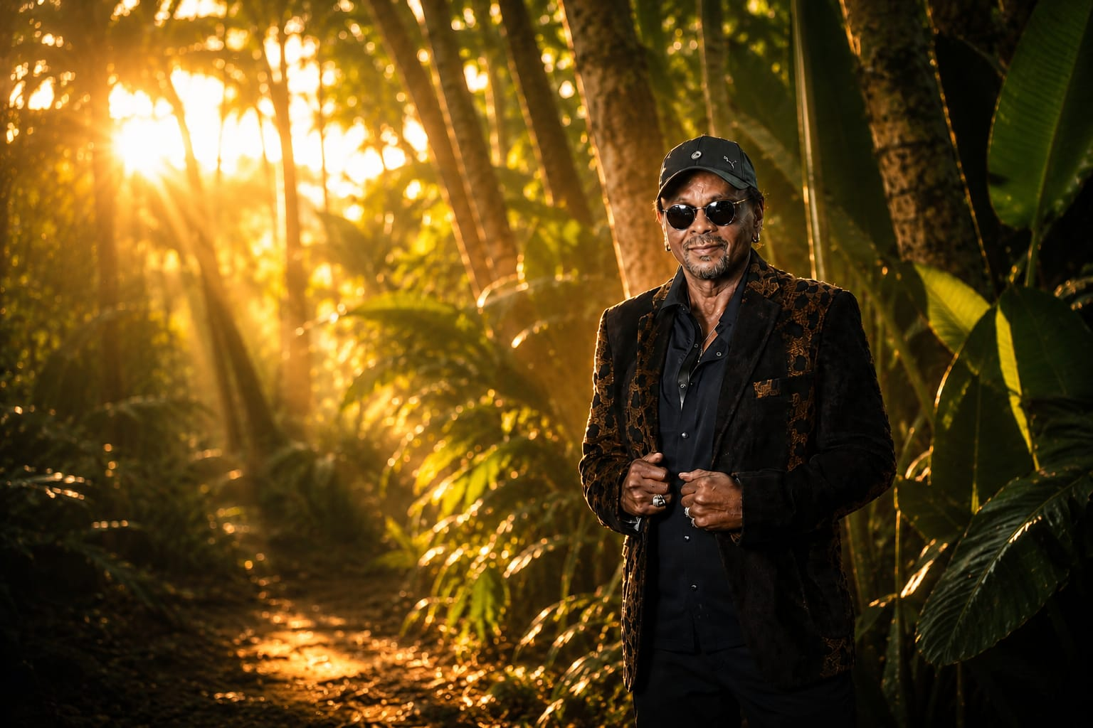
EPISODE III
The Sensitive Warrior

Rising, Leading, and Changing the World
Table of Contents
Introduction: The Warrior Within — Peter Coyote
Chapter 29: Luke Goss — Warriors Sit Within Truth
Chapter 30: Dr. Tom Falkenstein — Redefining Manhood
Chapter 31: Scott Barry Kaufman — Strong With Your Sensitivity
Chapter 32: Will Harper — The Sensitive Warrior Spirit
Chapter 33: Dave Reno — It's Been Raining a Long Time
Chapter 34: Pastor Marvin White — Rising Up Together
Chapter 35: Andy Lightfoot — One Tribe
Chapter 36: Arthur Aron & Elaine Aron — Advisors and Warriors
Chapter 37: Dr. Jed Diamond — The Calling
Chapter 38: William Allen — A Clarion Call
Chapter 39: Saamdu Chetri — The Strongest Human Being
Chapter 40: Will Harper & Juri Masaki — Japan's Quiet Revolution
Chapter 41: Andrew Reis — A Tradesman's Awakening
Chapter 42: Peter Coyote — The Warrior's S.T.Y.L.E.
Chapter 43: Mark Jamison — Sensitivity at Visa
Chapter 44: Greg Johnson & Cecil Williams — Lead With Sensitivity
Chapter 45: Alanis Morissette — Born to Support HSP Leaders
Chapter 46: Dr. Tracy Cooper — Conscious Leadership
Chapter 47: Asher Freund — The Sensitive EMT
Chapter 48: Dr. Elaine Aron — The Sensitive Leader's Style
Chapter 49: John Hughes & Daniel Miller — The Next Generation
Chapter 50: Jacquelyn Strickland — Rise Above
Chapter 51: Rev. Marvin White — Love and the Metaphysical
Chapter 52: Susan Fisher-Crooks — Pass It Forward
Chapter 53: Scott Barry Kaufman — Embrace the Unknown
Chapter 54: Kokoi Baldo & Alanis Morissette — It's a Gift
Chapter 55: Luke Goss — Tenacity of Spirit
Closing: The Time Is Now — Peter Coyote & Luke Goss

Introduction
The Warrior Within
Peter Coyote — Narrator
A warrior is someone who embodies personal strength, especially inner strength and the courage to face challenges head-on. Especially in today's world of disinformation, a true warrior looks deeply to find the truth and speaks it.

— — —

Chapter 29
Luke Goss — Warriors Sit Within Truth
Luke Goss — HSP Actor, Artist, Author, Director
In my experience, the warriors of men that I have been blessed to encounter — whether they're straight, whether they're gay, whether they are asexual, whether they have yet to understand themselves fully within — the warrior of a man that I encounter is a man that has the courage somehow to be himself despite the grisly appearance or not. I think warriors sit within truth.
And these days, to be truthful takes a lot more courage — because we're fighting the ever-accruing of these rules that contradict chemistry, interaction, trust, instincts, the ethereal. We know from the research that there are really strong issues and problems for men who have internalized very rigid ideas of what it means to be a man.
I'd say to most men who know that they sit within a great sensitivity: truly take a deep breath and know that they should address the truth of this first.

— — —

Chapter 30
Dr. Tom Falkenstein — Redefining Manhood
Dr. Tom Falkenstein — HSP Clinical Therapist & Author
If you look at the suicide rates, if you look at who's in prison, if you look at the news — who's engaging in terrible acts of violence — it is usually men. They're more likely to suffer from depression. Men are still less likely to ask for help when they have issues, when they face challenges or go through a crisis. So I feel like by adding being emotional, being sensitive, being a deep thinker, being reflective — by adding all these words to what it means to be a man — I think we're really moving forward.

— — —
Chapter 31
Scott Barry Kaufman — Strong With Your Sensitivity
Scott Barry Kaufman, Ph.D. — HSP, #1 Psychology Podcaster in the World
I completely agree. And being attuned to it and having that self-regulation capacity and those resiliency skills to know yourself well — self-acceptance is huge if you're a highly sensitive person. And knowing yourself very well and being able to also have the healthy assertiveness to create those boundaries around yourself so that you can stay sane and healthy and happy.
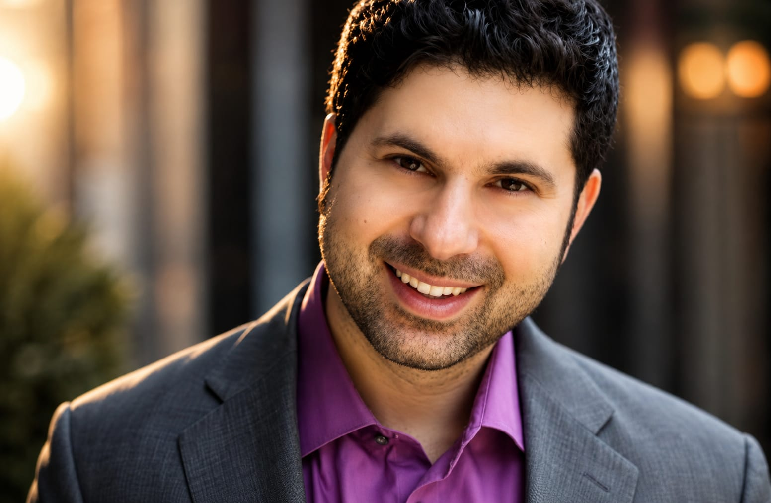
Whenever I think about what does it mean to be a good man, I think: what does it mean to be a good person? And how are those two questions really fundamentally different from each other? Growing up and trying to be a man and being a good person does involve an aspect of care. The care aspect of it has to be a part of being a good man. But it also does involve being strong with your sensitivities. To me, being able to be sensitive and to use that in positive, productive directions is being a real man.
— — —

Chapter 32
Will Harper — The Sensitive Warrior Spirit
Will Harper — The Sensitive Director
Let me add one to that, Scott. I see that sensitive warrior spirit in a lot of my brothers. Your strength isn't in alpha male armor. It's in your empathy. You're that cool guy — the optimist who feels deeply. Whether you're not so sensitive or somewhere in the middle, the highly sensitive guys add a whole new dimension to the sensitive equation. It's worth getting under the hood because they can make great heroes and leaders. Their unique power to inspire and lead with heart is just what we need in the age of masculinity identity crises. It's time to warrior up in a new way, leaving behind the outdated alpha dog mentality. Pop culture, take notice.
It's time for highly sensitive men to get busy.
Peter Coyote — Narrator
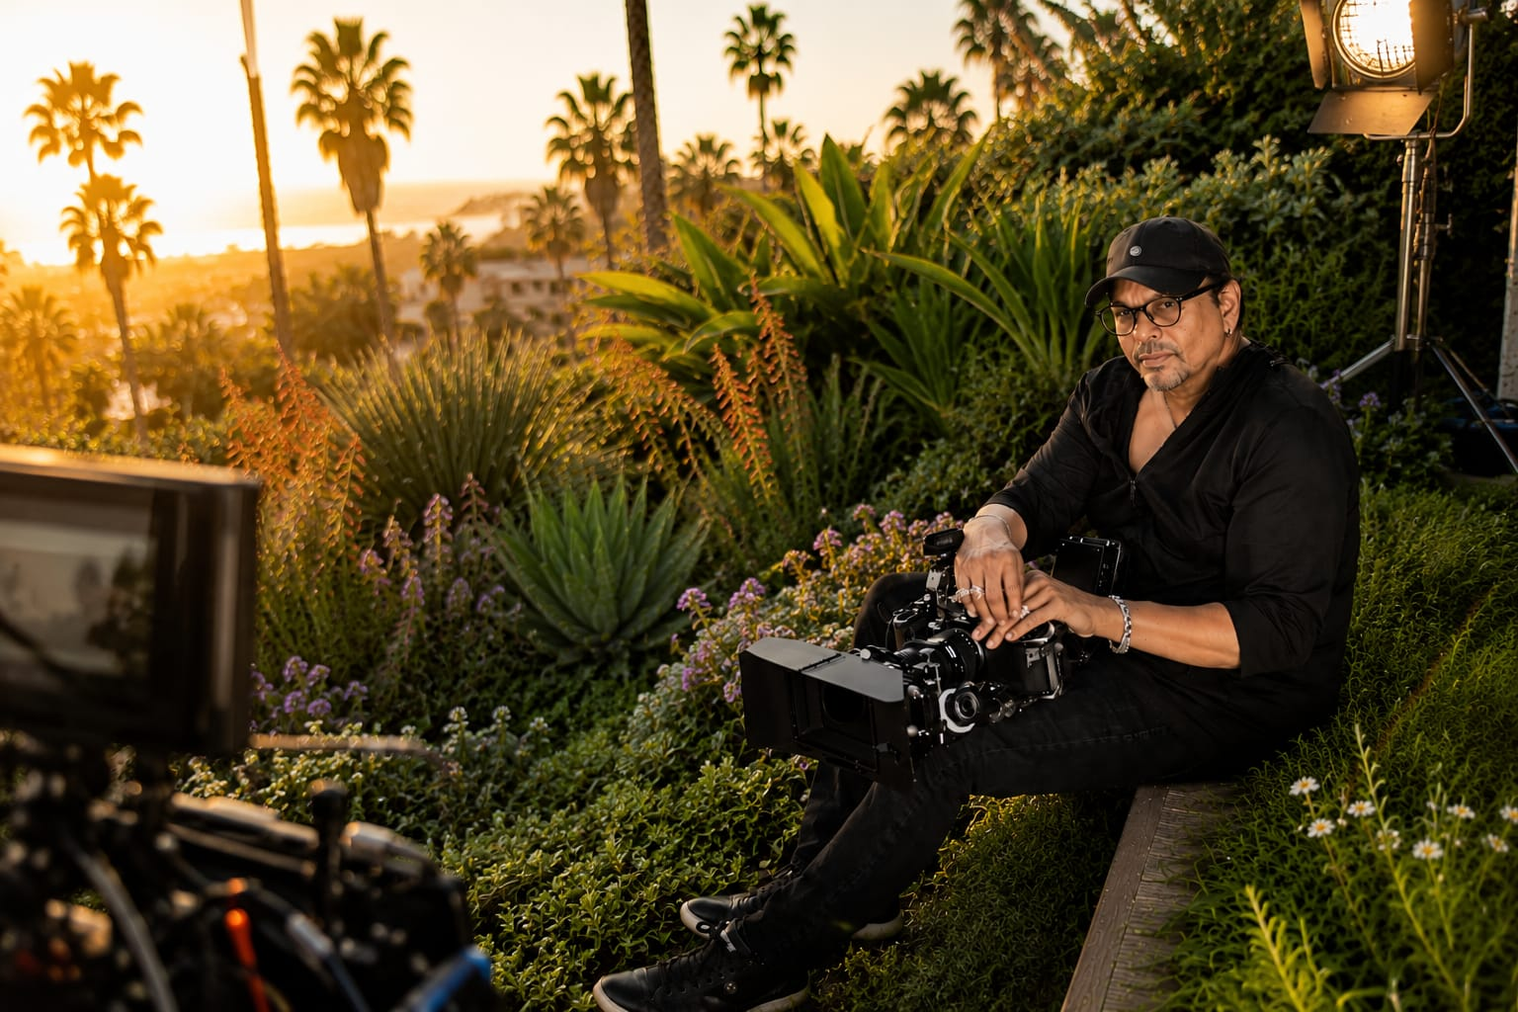
Speaking the truth today can require more courage than any physical combat. Highly sensitive men are perfectly equipped to be this kind of warrior — and how much the world needs them.
— — —

Chapter 33
Dave Reno — It's Been Raining a Long Time
Dave Reno — Musician & IT Expert
I've been searching a long time to figure out what this is. I was called a sensitive person my whole life — a crybaby many times, told to man up. Big boys don't cry. And it's been raining a long time. A long time it's been raining. And this has helped to make it so that the sun has come out.
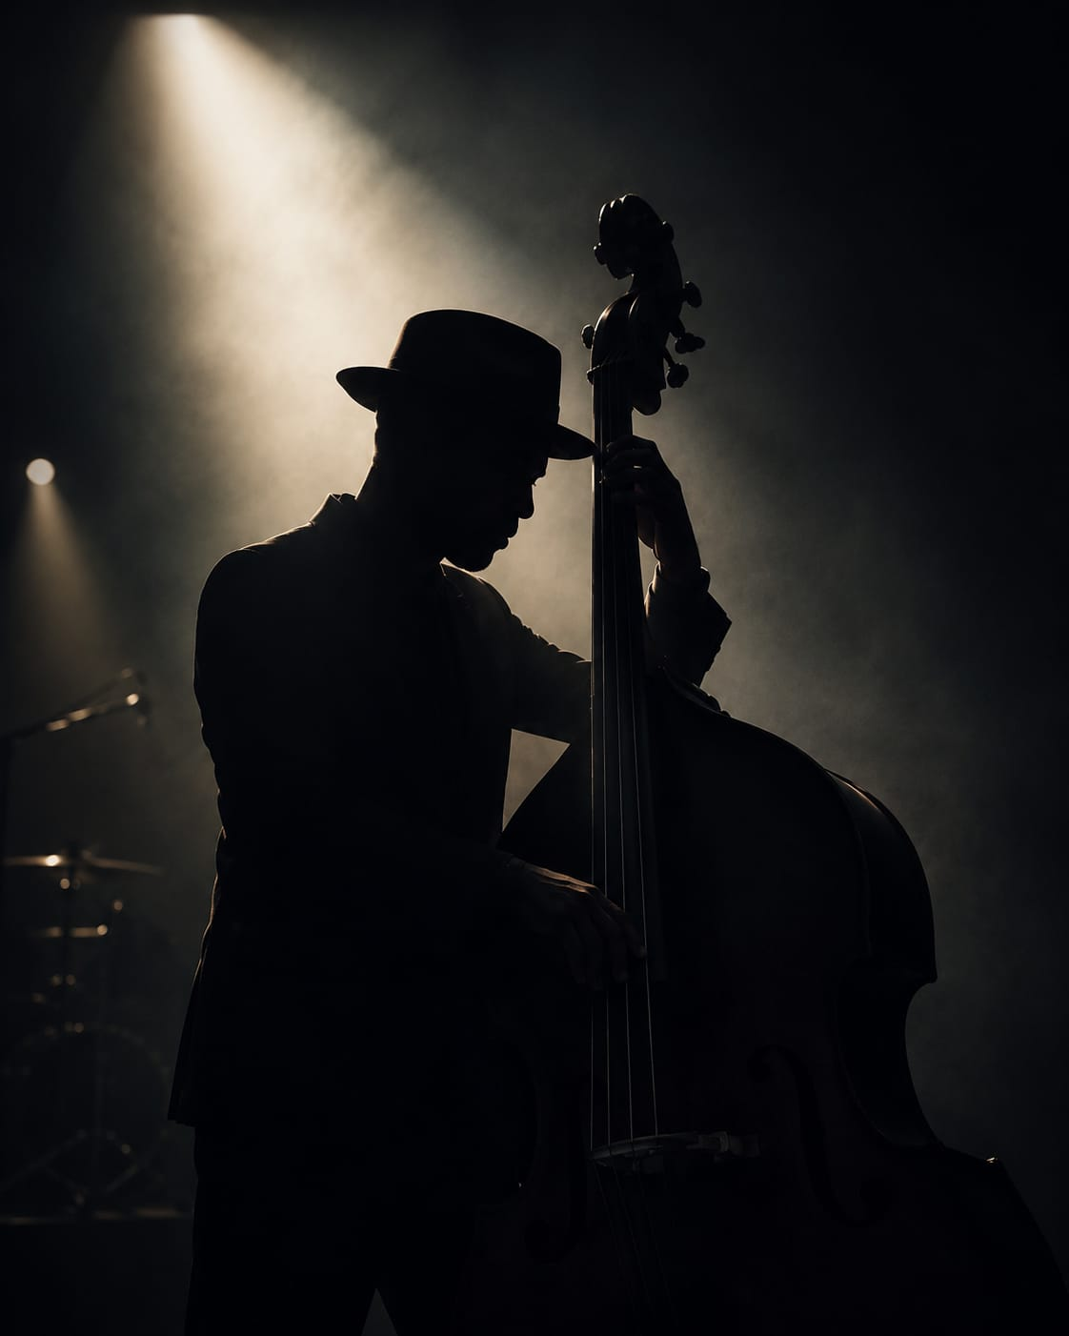
— — —

Chapter 34
Pastor Marvin White — Rising Up Together
Pastor Marvin White
This idea that all sensitive people have an opportunity to rise up together — that's groundbreaking to me. That we can actually find each other, that we can actually support each other in this rising up, and that we are not alone in this. I think the more we come together, the louder we can be in our sensitivities. And we will call out to others as well, because we are seen as a force.
— — —
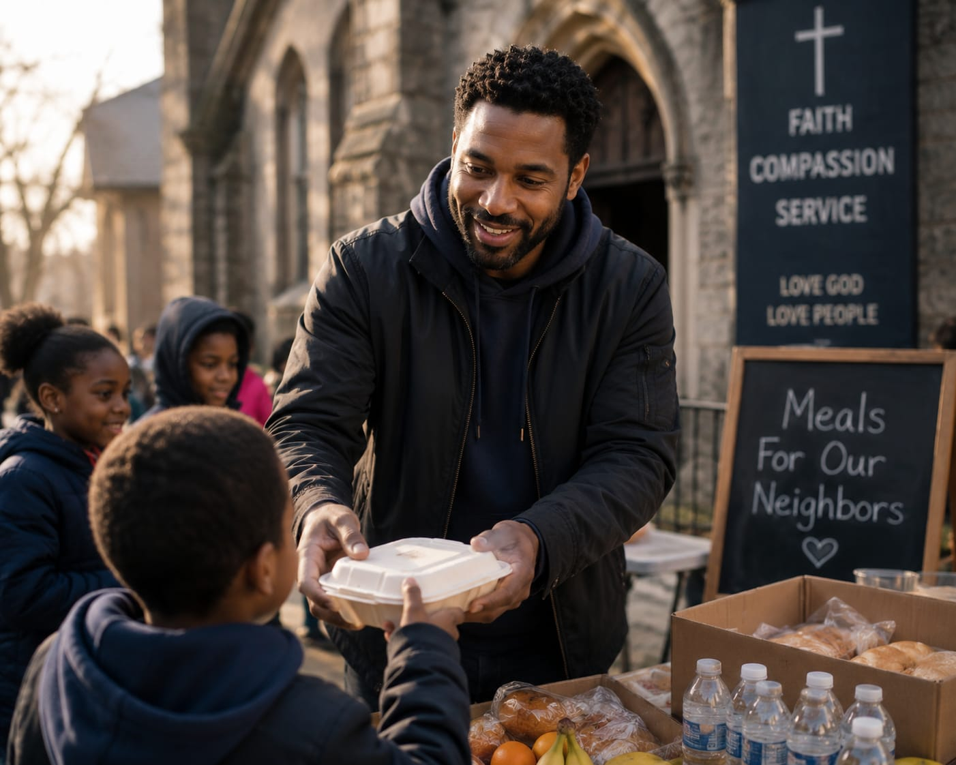
Chapter 35
Andy Lightfoot — One Tribe
Andy Lightfoot — HSP/HSS, US Army, Railroad Engineer, Police Force, PTSD Survivor
It's all one tribe. It's a tribal band. It's a smaller tribal band. And the fact that it's unknown — that causes mystery in the mind.
Luke Goss — HSP Actor, Artist, Author, Director
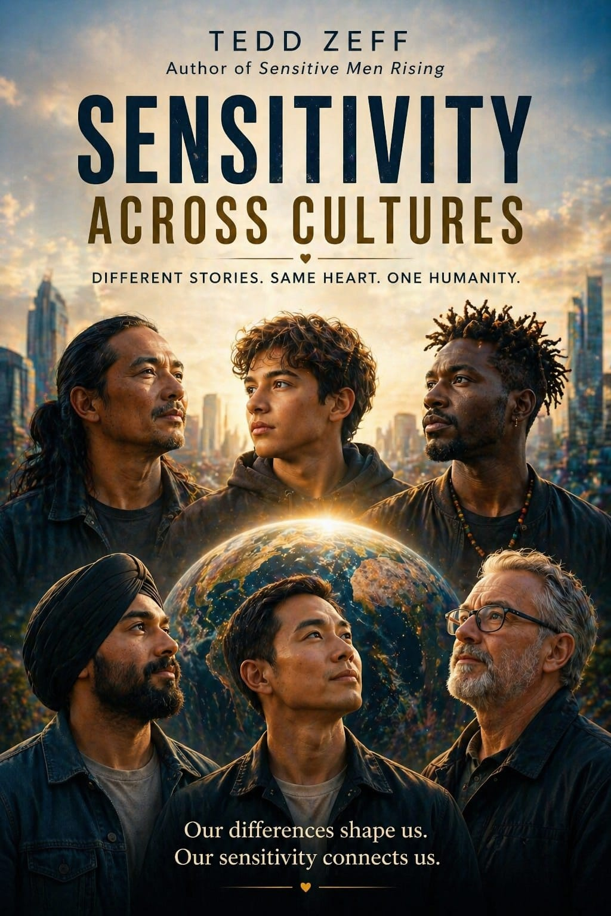
Most highly sensitive men I know know they're highly sensitive. They just don't know what it is. They would just say they're softies or they're babies. No — they're the men in a crisis that will be the men they were meant to be. They will gather arms if necessary to defend the village or the ones they love, within grace and sadness that they would have to do so.
— — —

Chapter 36
Arthur Aron & Elaine Aron — Advisors and Warriors
Dr. Elaine Aron — Clinical Researcher, Psychologist, Bestselling Author
In India, there's this class of people who are the warriors and the kings, and this class who are the advisors and the priests. When you look at how they're described traditionally, the advisors and the priests are the highly sensitive ones. And when the military and the royalty perform well, they're taking advantage of the deeper thinking about what's going on and the advice they get from the highly sensitive ones.

Dr. Elaine Aron — Clinical Researcher, Psychologist, Bestselling Author
Every culture needs the men who are fast in their actions and decisive and all of that, but they also need — right at their shoulder — the sensitive men who are seeing the big picture and warning them against taking sudden action.

Chapter 37
Dr. Jed Diamond — The Calling
Dr. Jed Diamond — Ph.D., Author, Therapist & Men's Specialist
I really feel that we all — men in this case — are really being called upon. There really is a rising and a calling for men to step forward in the ways that sensitive men have always stepped forward at times of crisis, at times of importance, to draw people together when our communities are under threat, when our families are under threat.
These are the times that sensitive men and powerful men — this is not a sensitive but can't get things done. It's a powerful, spiritual warrior kind of energy.
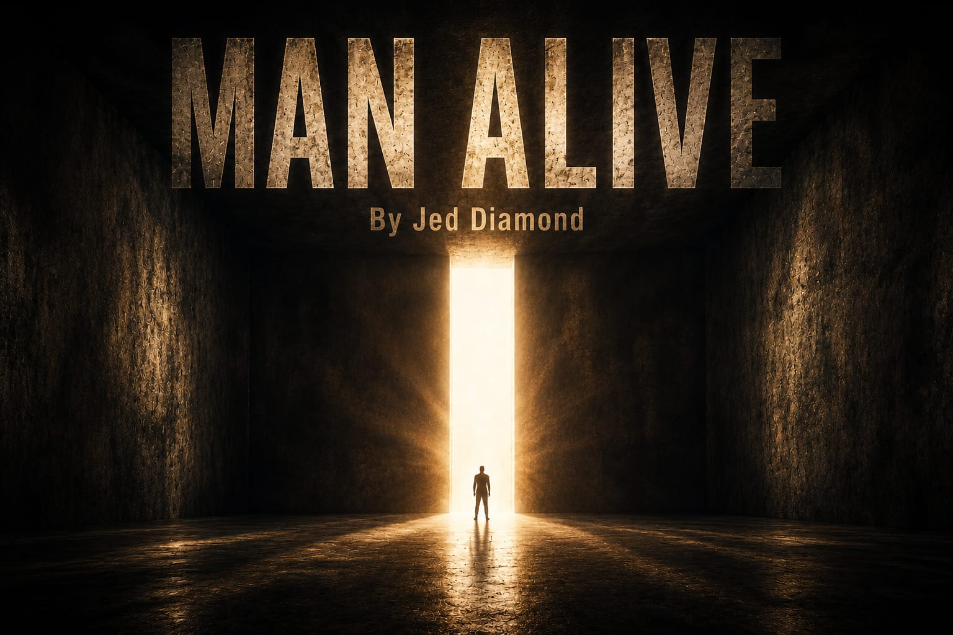
— — —

Chapter 38
William Allen — A Clarion Call
William Allen — HSP Author, On Being Sensitive Men
Sensitive Men Rising is a clarion call for highly sensitive men to rise up and model the behaviors that we know the world needs right now. Highly sensitive men are important to show that we can do these things, still remain masculine, still be human, and not annihilate ourselves because we've broken some old archaic centuries-old rules about what a man is supposed to be.
Will Harper-Sensitive Director
Brother Bill, I believe that sensitivity is not merely an afterthought in the realm of masculinity. It is an enduring truth, grounded in strength and sensibility. It unites us all.
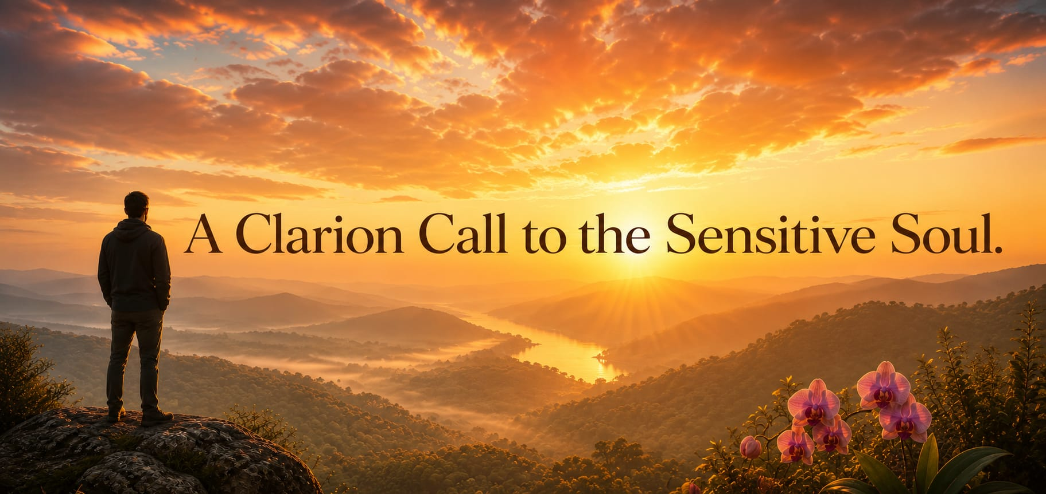
— — —

Chapter 39
Saamdu Chetri — The Strongest Human Being
Saamdu Chetri — HSP, Former Ministry of Happiness Director, Kingdom of Bhutan
A sensitive person is the strongest human being on earth because he or she would have realized the truth — the absolute truth, the absolute reality that is in science and spirituality. And they can then bring a transformation the way that they would want the world to be a happier and a saner place to live. This can be done by the sensitive people.

— — —

Chapter 40
Will Harper & Juri Masaki — Japan's Quiet Revolution
Will Harper-Sensitive Director
I've worked around the world meeting a kaleidoscope of sensitive souls. But it was in Japan — the land of the rising sun, surrounded by cherry blossoms and quiet temples — that I felt a unique fusion of calmness and unease. Here, among the quiet strength of this robust nation of pride, resilience, and sensitivity, I sensed a slight reluctance to fully embrace sensitivity. Many of the guys, with their sensitive battles, unspoken fears, and overwhelming pace, were blurring the line between tradition and inner truth.
And then I met Juri Masaki — a beacon of light for Japan's sensitive souls. In her writing and coaching, she guides many towards self-acceptance, gently encouraging them to embrace their true selves.
Juri Masaki — HSP Sensitive Career Coach & Author
The Japanese male men — we are not allowed to show the sensitivity. They push themselves so hard into non-sensitive society so that you don't feel anything. You gotta be strong. You gotta be macho all the time. You're not supposed to cry. You're not supposed to think anything deeply. So that's a big part of our culture.
And I say to them, 'Well, you are highly sensitive, so be it.' But they're like, 'No, if I admit I am highly sensitive, then I won't be able to live in this life. I don't think I fit into this society anymore.'
A lot of highly sensitive men, when they come to me, they're like: 'I may look really macho and strong, but to be honest, I think I'm really soft-hearted. I can't even date anyone because I'm so afraid of being dumped.' They suffer from this tender softness that they have. They don't know how to accept it.
We can be sensitive and be strong. We're not strong like brutally or physically, but our mindset can be really strong, stable, powerful, energetic — and still serve the society without being brutal.
Will Harper-Sensitive Director
Juri, it's a real paradox. For me and other sensitive men — like the Sioux Chief Sitting Bull, a sensitive man and a warrior — he defined warrior as one who sacrifices himself for the good of others. His task was to take care of the elderly, the defenseless, those who cannot provide for themselves, and above all the children, the future of humanity. He was a quiet man with purpose and empathy.
Juri Masaki HSP Career Coach &Author
There are a lot of Japanese men who are quiet, silent, but they stand up for their family or their community or their friends — even themselves. When they do that, they are so strong that no one can beat them. He's so committed and so strong, but he's just so quiet, and he just does it.
Sensitive doesn't mean weakness. Sensitive means you're very rich. You have a very rich inner life, and it's beautiful. And it's beautiful to be yourself. That's the strength in highly sensitive men.
Will Harper-Sensitive Director
In the Land of the Rising Sun, I discovered a whole lot more than flowers and ancient tradition. I found a quiet revolution where men are learning to be warriors of the heart. I believe that in this world, man is not alone. We reject isolation and choose unity, fostering hope over despair. This is our call to action — the anthem of the sensitive warrior, a song of courage, authenticity, and unwavering compassion.
— — —

Chapter 41
Andrew Reis — A Tradesman's Awakening
Andrew Reis — HSP Tradesman, Australia
My name is Andrew Reis. I'm an Australian fella. I'm a highly sensitive person. I feel everything.
I went through a high conflict divorce and my mind was in a fog all the time. I was totally disconnected from my body. I got backed into a psychological corner. I was in a mess. I chose to walk away. I didn't hurt myself and I didn't hurt anyone else. A lot of men take their lives every day because of this. I didn't know who I was. I was a broken man.
Then on my phone, a thing came up about HSP and I'm like — what's that? I clicked on it and I started reading about highly sensitive people and I just got all these tingles. That's me. That's me.
I'd be cruel to myself for being so sensitive and I didn't know that's what I was. And now I express my love to people and to all things in this world — it's unbelievable. I've got the heart the size of Ayers Rock. I've never been able to feel it really until recently and now it's open and I feel everything.
My purpose in life is to facilitate change within Australia, within the domestic violence in the courtroom. And men cop it. There's a stigma in Australia that is woefully against men. And the only way I can help is — I help heal men and women. I help heal everyone.
I was a tradesman for twenty-eight years — rough and tough and ready. We weren't allowed to cry as men, as boys growing up. You don't cry. And we learn not to express our emotions and feelings. I did that for many years. I suppressed that. And just because I was sensitive — there was a reason for everything. And that changed my life.
I was able to accept that part of me — that I was actually sensitive. What I was feeling was right. Rather than trying to suppress all those emotions, what I was feeling was actually normal.
If you ever get to the point, young man, that your sensitivity is killing you — don't give up, mate. There is so much more and you're so special. Allow yourself to understand what it feels like. Feel those emotions, feel everything. Because one day you'll get control of it and you'll live. So hang in there, fellas.

— — —

Chapter 42
Peter Coyote — The Warrior's S.T.Y.L.E.
Peter Coyote — Narrator
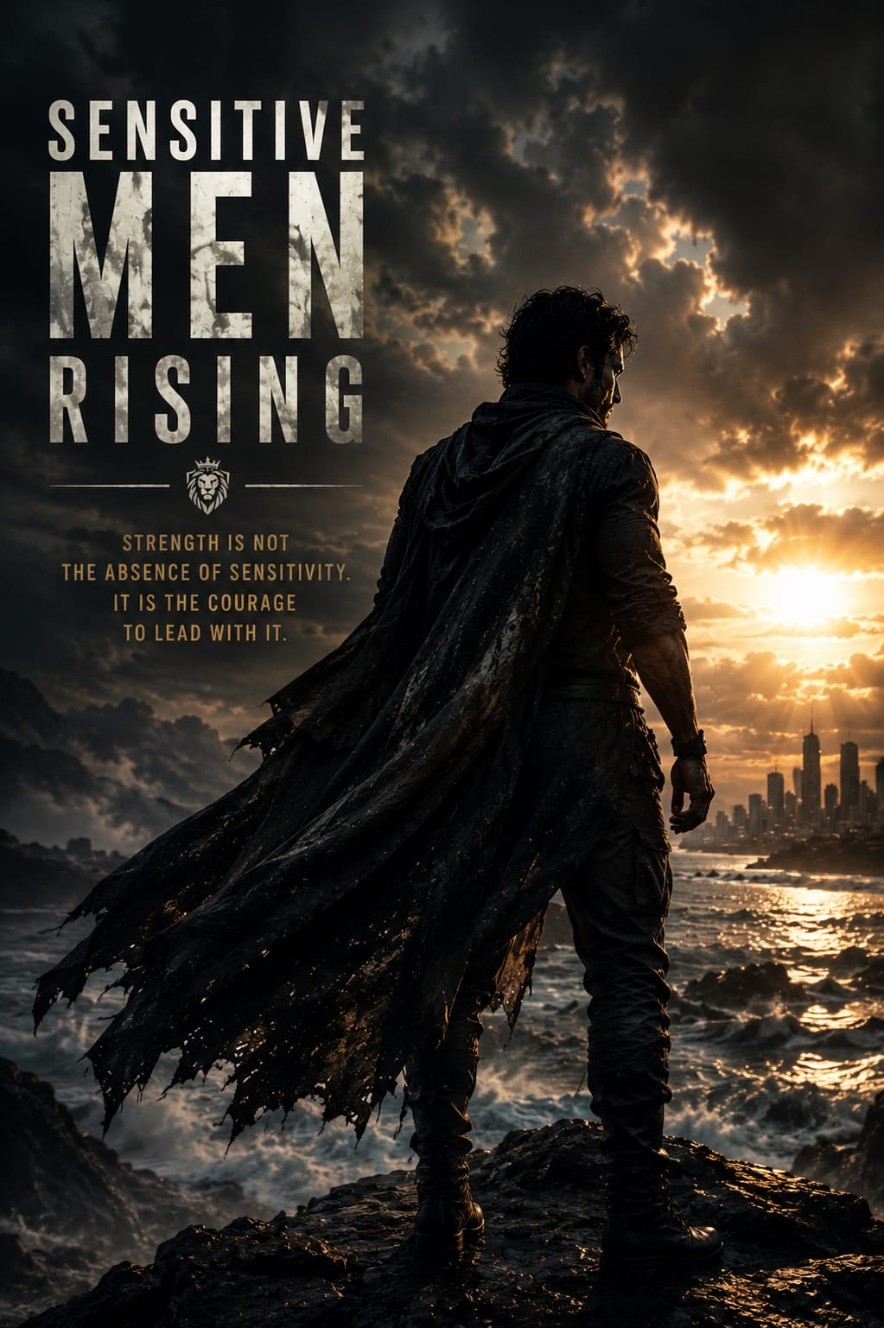
A warrior is above all a protector of his family, his community, his nation, and the world. He will fight for them if he must. We do not always think of warriors as being sensitive, but to be most effective, they have to embody all the qualities of a sensitive man, at least to some degree. They have to have style, as we've called it. Warriors must have a wise strategy for winning. They must have plenty of testosterone for pushing through their exhaustion when necessary. But they also have to strategically yield when the situation calls for it, coming back to win later.
Leaders. They see all the subtleties going on, especially the emotional state of their team. Finally, and most important, they must have empathy for those they protect, and also use their empathy to read the thoughts of their foe. S-T-Y-L-E.
— — —

Chapter 43
Mark Jamison — Sensitivity at Visa
Mark Jamison — HSP, SVP & Head of Global Clients, Visa Inc.
At Visa, I run a global organization. We facilitate commerce everywhere in the world. I have teams in fourteen different centers around the world — in Asia, in Latin America, in Europe. All those cultures are different. And what I've learned is that when you go into those cultures with some humility, there's a ripple effect that goes far beyond. That actually is an enabling superpower that allows people to connect with you. Previously, I wanted to be this large, in-charge executive who had just flown in from the United States. They would have treated me very differently. But instead, by embracing your gifts — this sensitive trait — it's allowed me to be a much more effective leader at my company.
A number of years ago, a senior executive gave me feedback and said: 'Mark, you're an artist who just happens to do business.' And that really resonated with me because I felt like I had this dichotomy of how I was supposed to act versus who I was. And once I realized that when you embrace the whole of what you can bring, you become a much more impactful, much more influential, and much more inclusive leader.
In a meeting, a twenty-seven-year-old woman asked the senior executive team: 'Is it okay to cry at work?' And the discussion we had was: look, we believe as a company you should bring your whole self to work. We are created to be emotional human beings with compassion and empathy. And if we don't embrace that, then all we're doing is limiting our potential as a company, as humans.
You can perform at a very high level, have high standards for excellence, and do that while embracing your gifts of sensitivity. It's a falsehood to say that sensitivity and compassion are a weakness. It is the opposite. When you bring those gifts to the workplace, you are stronger. Your team is stronger. They have psychological safety. They perform better, and everyone is uplifted by it.
— — —

Chapter 44
Greg Johnson & Cecil Williams — Lead With Sensitivity
Greg Johnson — Composer & Co-Producer, Sensitive Men Rising
I hope to see in my lifetime where we can tip the scale and have us lead as a culture — lead with our sensitivity, that that's where we start.
I just love sharing my sensitive story because a lot of men do not think it's cool to be called sensitive. The legendary Cecil Williams is a case in point. I observed, studied, and applied some of his compassionate acts of kindness towards others, and it is what gave me my strength and style.
Cecil Williams — Co-Founder of Glide Memorial Church
My experience is wrapped up in Martin Luther King. My experience is wrapped up in the women's movement and the movement of the gay liberation people.
Greg Johnson Pianist, Musician Producer
Cecil Williams is a deep man and was always ahead of his time. His core implementation of leadership exemplified the spirit of a quiet leader — a leader who observed deeply, a leader who showed restraint, modesty, and tenacity. This is all a part of the highly sensitive men's leadership style through strategic yielding. He taught me and other like-minded brothers to walk tall and to create our own reputable path as caring and compassionate men.
Chapter 45
Alanis Morissette — Born to Support HSP Leaders
Alanis Morissette — 7× Grammy Award Winning Singer-Songwriter & Musician
If I can do anything, one of the things I feel I am born to do is to support HSP men and HSP women in positions of leadership.
Because we're the ones that are going to take everything into account — financial, environmental, psychosomatic, neurobiological, biochemical. We're going to take everything into account. And the fearless leaders that are HSPs are the ones I want to follow into a towering inferno.
When an HSP is on fire and intended and clear on the mission — look out. Look out.
It's our moment in the sun in a way — because I've always felt that it's seen as a boon and it's celebrated. The thought that there's space being made for men to be whole, to be vulnerable, to be powerful, to need, to lean, to reach out — to also want to have a life experience that matches who they are temperamentally. The more HSP men can be having this conversation in public, I think the better we'll be.
— — —

Chapter 46
Dr. Tracy Cooper — Conscious Leadership
Dr. Tracy Cooper, Ph.D. — HSP Professor, Author & Consultant
If we're in leadership positions, if we're educators and we're healers and we're spiritual leaders — all of these things — we need people to be in these kinds of roles. And sensitive men are one of the best kinds of people to inhabit those roles because we have this wonderful trait that has this wonderful ability to pick up on subtle stimuli. We know when someone's not feeling well, when someone's upset, and sometimes we know what to do about it. Sometimes we also know how to just hold space, but be able to listen very deeply. So there's so much to be said for being a real and authentic human being that's capable of showing up in that way. We're wiser if we're deeper processors. We need to put it to work.
We really do need calm, centered, critical, creative thinking people that are capable of conscious leadership — especially in our men.
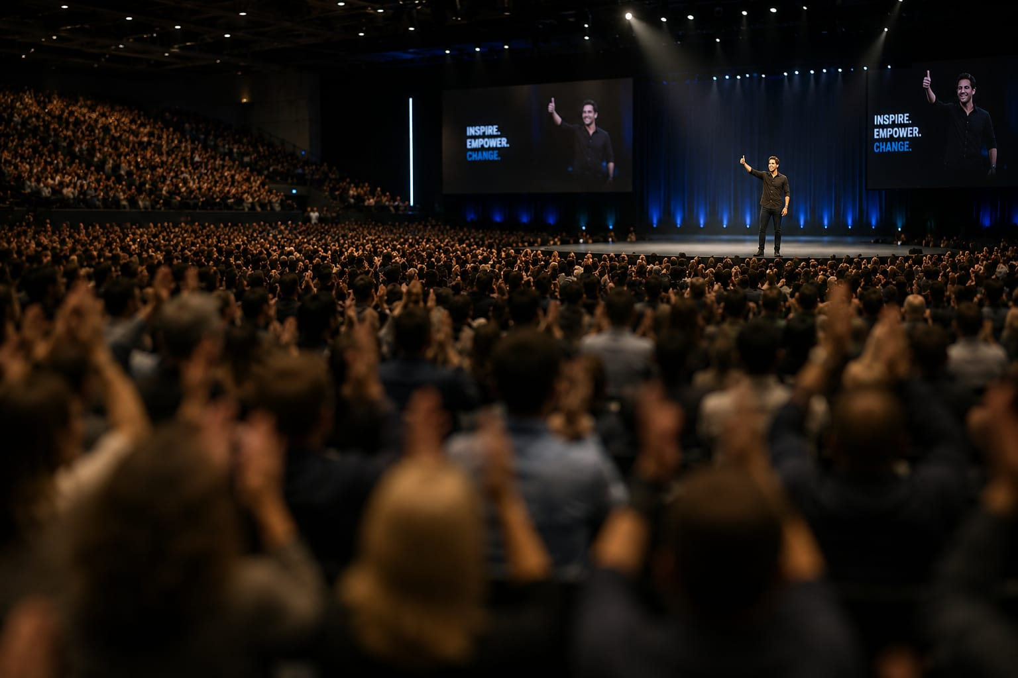
— — —

Chapter 47
Asher Freund — The Sensitive EMT
Asher Freund — HSP/HSS, Former Emergency Medical Technician
How do I square being an emergency medical technician with being highly sensitive? About my fifth or sixth day of training, I was on the verge of quitting. I drove home and I was crying — I'd had a difficult day and the EMT who was training me was very harsh and used a lot of tough love.
I was on the verge of quitting. I didn't know if I was cut out for it because the stakes were so high. And I think that the very reasons why I would get so overwhelmed in the beginning — the feeling of just a wave of sense data washing over me when I would get on scene — all of this was just too much in the beginning.
But then once I just got used to it and settled in, I became a really good EMT because I would be able to notice what was needed. I would be able to see the scene, take it in, and identify exactly the way in which I could be of most benefit in that moment.
I found myself connecting deeply with patients because the needs of people who are sick and injured were not just physical. People who were sick and injured were also often experiencing a lot of fear. And I would find myself responding to them not just in medical ways, but also just as a fellow human being. I would find myself holding people's hands because I was just moved by the fear or confusion that I could see in them.
Chapter 48
Dr. Elaine Aron — The Sensitive Leader's Style
Will Harper-Sensitive Director
The intersection of sensitive men and leadership has long captivated Dr. Elaine Aron, prompting her to delve into deep thought and share some of her findings.
Dr. Elaine Aron — Clinical Researcher, Psychologist, Bestselling Author
Sensitive men have a whole different style of leadership when they're leading a group — which is to listen to what people have to say and then only, if necessary in the end, to step in and shape the situation. Because so many leaders want to be seen as the leader and very strong, and other people maybe don't get a word in because their egos are in the way. But the sensitive leader tends to stand back and let others shine.
Sensitive men are often wonderful in that way. That's why you often see them in professions where empathy is helpful — or in business situations where they're often the ones who do what we call moral leadership. There's sometimes task leadership — getting the job done — and then there's the morale leader who sees that everyone in the group is feeling okay and able to contribute. So it's to everyone's advantage when a sensitive man steps in with his empathy and pulls people back into the group and makes them feel good again about what they're doing.
Sensitive people do best working on their own, and they become leaders in their field by thinking creatively on their own and not necessarily following the trends, so that in time their ideas are often the most successful.
We need the sensitive men who are doing very well to step forward and be proud of their sensitivity and inspire the world with this trait — with this trait that is giving them these advantages. They kind of owe it to the world to speak up about their sensitivity so that we can all embrace it and all value it.
We want to see sensitive men in the place they belong in society — right up there, giving advice, and being appreciated for what they have to say.
I've always imagined that sensitive men should come together and talk together about what's happening in their lives. And I imagine this film as a chance for men — sensitive men — to watch other sensitive men and to feel a bond and to know that they are brothers, that they have this thing in common, even though it's completely invisible.
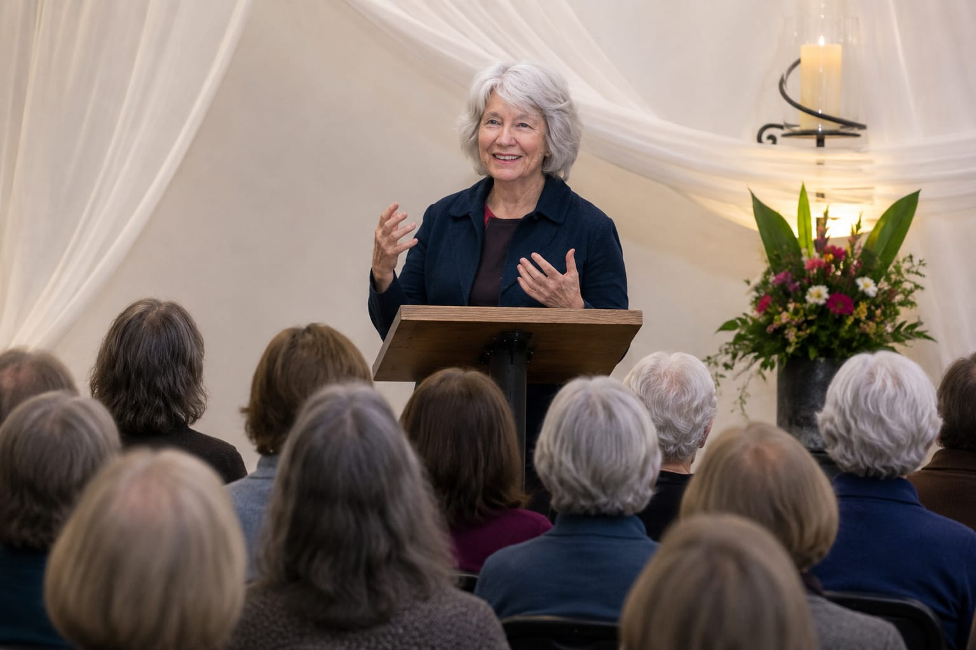
— — —

Chapter 49
John Hughes & Daniel Miller — The Next Generation
John Hughes — Expert on Business Leadership
I'm a huge believer that we're each given a gift and it's our job to figure out what that is — and it's a gift that we need to give back out.
We really do know what we want to do, just really, really deep down. We really do. And there are these layers — I call them layers — and we're layered from pretty much the moment we're born. I love to be challenged.

Peter Coyote — Narrator — Three Reasons HSPs Make Excellent Leaders
John Hughes, an expert on business leadership, gives three reasons why HSPs make excellent leaders. First, they see all the subtleties going on, especially the emotional state of their team. Second, because they process before acting, they naturally fall to the background, allowing team members to speak freely, share, and shine. Third, they exhibit what is called resonant leadership — resonant leaders seem to say and do the right thing at just the right time. This isn't luck or magic. It's their innate ability to feel deeply, process richly, and patiently consider the right words and actions for their moment.

Daniel Miller, Ph.D., LMHC — HSP Professor & Psychotherapist
For the millennial highly sensitive men, what I would say is: we are at the age now where we're becoming the fathers and the mentors and the coaches and the teachers. So I think it's really important for us to create those environments and those spaces for the next generation of highly sensitive boys and men coming up, where they can feel free to fully embrace who they are and their sensitivity.

Soborno Isaac Bari — Math Professor, NYU Student
Feeling empathy and compassion is one of the best characteristics and traits for a leader. And that's why I believe that all highly sensitive children — including the highly sensitive children that might be watching this right now — they are going to shape our future.

Mark Jamison — SVP, Visa Inc.
About 50% of our company is either millennial or Gen Z. The world is falling apart — there's political divisiveness, the environment is being destroyed. And they just need a different model. When they see options that bring hope and sensitivity and a much more integrated approach to problem solving, I see them embrace it with arms wide open.

Chapter 50
Jacquelyn Strickland — Rise Above
Jacquelyn Strickland — HSP, Retired Clinical Therapist, HSP Gathering Retreat Co-Founder
We need to come together to come up with a new way. This male dominance has caused too much hurt, pain, and oppression, and it still has a grip on so much of the world. And I just ask you all to help us rise above the patriarchy and the damage that it has done and can do and will do. And I hope it encourages men to show up, be seen — because we can be sensitive, strong, vulnerable, and we can use our skills to make the world a better place.

— — —

Chapter 51
Rev. Marvin White — Love and the Metaphysical
Rev. Marvin White
I don't have to grow into a certain kind of monolithic idea of masculinity or manhood. We owe it to ourselves on this earthly plane to understand that we are spiritual as much as we are physical. It's about the metaphysical — how we transform this world into something about love, and love for ourselves and love for one another as well.
— — —

Chapter 52
Susan Fisher-Crooks — Pass It Forward
Susan Fisher-Crooks — HSP, Founder & President, Walt's Waltz Foundation
You are beautiful and you are the people we need so much right now in this world. We need you to be able to step out and be who you are — because there's so much division. And as highly sensitive men, you can understand this at a different level. Because if you want to think about your suffering — okay, you had your suffering — but now you've helped a child not have to go through the things that you did.
It's sort of a way of passing it forward. How can I help create this momentum of change that we need to see and also be role models for the young men of the future? This is important and it could even save lives.

— — —

Chapter 53
Scott Barry Kaufman — Embrace the Unknown
Scott Barry Kaufman, Ph.D.#1 Psychology Podcaster in the World Author, and Public Speaker
How can we help men embrace the unknown more — with more confidence, more openness to whatever arises — without fear and without self-judgment, and not running away for fear that that exposure, that vulnerability of that sensitivity will somehow make them look less manly? If anything, it'll make them look more manly if they integrate it into their lives. So we really must not fear the sensitivity as men — and not keep it in the shadows as though it's something that we need to cordon off from the rest of us, or else we are not allowed to adopt the man identity.

— — —

Chapter 54
Alanis Morissette — It's a Gift
Kokoi Baldo-Song Writer, Musician
It's not a weakness. It's a gift. It's a gift. Sensitivity is a gift.
Alanis Morissette-7time Grammy Award Winning Singer, Songwriter Musician
It's our moment in the sun in a way — because I've always felt that it's seen as a boon and it's celebrated. The thought that there's space being made for men to be whole, to be vulnerable, to be powerful, to need, to lean, to reach out — to also want to have a life experience that matches who they are temperamentally. The more HSP men can be having this conversation in public, I think the better we'll be.
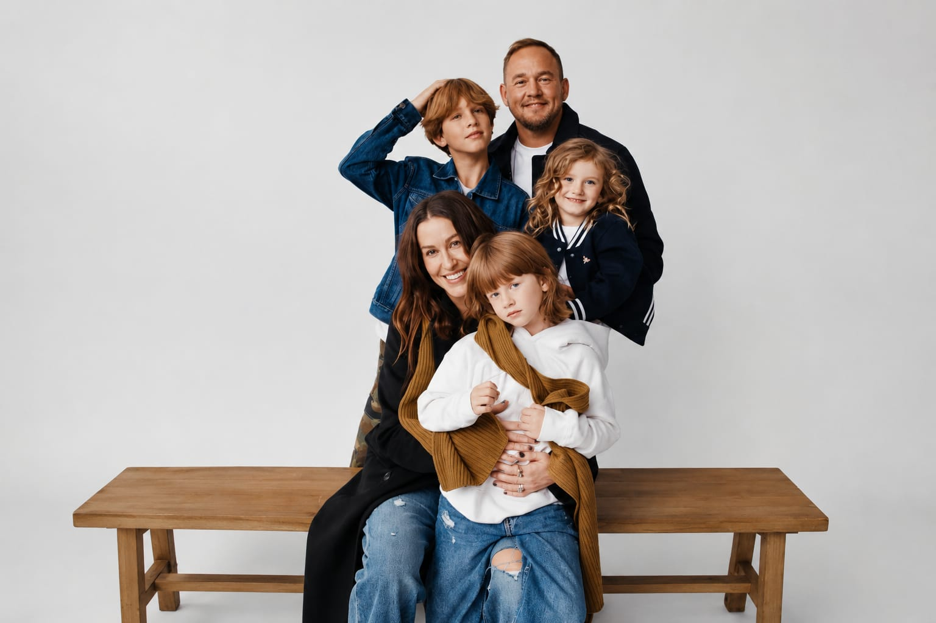
— — —

Chapter 55
Luke Goss — Tenacity of Spirit
Dr. Tom Falkenstein HSP Clinical Therapist Author
Highly sensitive men are out there and I think they play an important role in developing our understanding of masculinity. So I really feel it's time to challenge this very rigid traditional image of what it means to be a man. And I think highly sensitive men can really help to change that.
Will Harper-Sensitive Director
So, we can save the world.
Dr. Tom Falkenstein HSP Clinical Therapist Author
Well, I don't know — but I think we can try.
Luke Goss HSP Actor, Author, Director
And highly sensitive people, I believe, are needed — because men that don't embrace energy within this sense of expression and creativity and language are hurting this planet. Literally, as we do this, there's war, ego, greed, money. And highly sensitive people, I believe, if we come together, we'll have a voice that says no. And who would have thought — maybe all these little sensitive men come along and say: no, we've had enough. I have. It's about love.

Brandon Lee Tankard
That's a beautiful, positive thing. Sensitivity is part of being human. And I think that so many of us — whatever gender you associate with, for various reasons — have been stripped of our humanity. Being sensitive is part of that. We have access to so many wonderful emotions and feelings and ways of expression, and sensitivity is part of that.

Luke Goss HSP Actor Author Director
And if men expect something of men, and we say in this documentary collectively — if we start expecting something of each other and helping men walk better with more integrity, more transparency, and let them know that their emotions should be regarded as great assets because it means they're conscious and they're in the room. Let's be tenacious with our spirits. Let's be tenacious with our purpose. And let's be tenacious with bringing this to fruition and representing the beauty and the facets that men can bring. That's what I would say.

Luke Goss — Final Words
Sensitive is and sensitive does. And any man or woman that tells me that there's less of me because of it, I'll say: God bless you. I look forward to your evolution of knowledge. Because they'll find out.
— — —
Closing
The Time Is Now
Will Harper-Sensitive Director
As we rally our sensitive troops, troubadours, and titans, let us not conclude with doubt or despair, but rather with a stirring sense of hope and optimism. In the vast tapestry of humanity, let's envision highly sensitive men as a beacon of change — the catalyst for a transformative shift in the prevailing narrative of masculinity.
Peter Coyote — Narrator
I hope this film has convinced you that right now the talents, the intuitions, the intelligence of highly sensitive men are more critically important than perhaps ever before. Working with the majority will be a beautiful partnership. So the real question is — what will you do to change the paradigm?
The time is now. It's time for sensitive men to rise.
Luke Goss — The Man I Am
A man forged from misunderstandings from those who just couldn't bother. But now better for it, and stronger for it, and strangely enough, even more sensitive for it. Ever proof the sensitive heart can weather the toughest storm without losing its destined design. That born design we all fight for, that I fight for and win for. To just be me. To be. To be free.

